

EXPERIMENTAL DATA ON HYDROGEN DISPERSION AND EXPLOSION FOR STANDARD BENCHMARK EXERCISE PROBLEMS

Deliverable D81 of the HYSAFE project
Contract No SES6-CT-2004-502630

Contributing HYSAFE WP-06 and WP-10 Partners
Fh-ICT, GexCon, FZK, HSL/HSE, UNIPI, UU

Updated version: 21 November 2007
Document revision: 1.1

Experiment ID | UU-01
Short description | 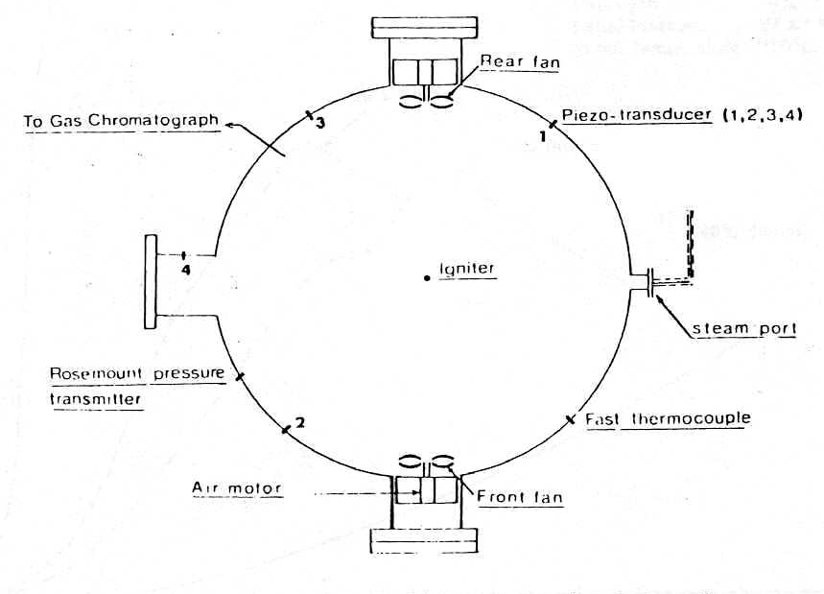  Deflagration of 29.5% (by vol.) hydrogen-air quiescent mixture in the 6.37 m³ closed spherical vessel (diameter 2.3 m). Central point ignition source. Initial temperature is 373 K, initial pressure 97 kPa.
What phenomena were studied | Pressure dynamics of hydrogen-air deflagration in closed large-scale vessel.
What phenomena/effects can be studied | Wrinkled flame front propagation and pressure build up.
Instrumentation | Pressure transducers.
Test variables | Hydrogen concentrations (only stoichiometric mixture is offered for SBEP).
Data description / Data completeness | Pressure records.
Data availability | Publicly available.
Source of data / Reference | Kumar R.K., Tamm H., Harrison W.C. Combustion of hydrogen at high concentration including the effect of obstacles. Combustion Science and Technology, V.35, pp.175-186, 1983.
Why were chosen | Large-scale experiment on hydrogen-air deflagration in closed vessel (published in peer reviewed journal). One of the possible scenarios in practice is deflagration in closed space. Convenient basic benchmark case to evaluate a model performance for: flame front propagation, pressure dynamics and absolute pressure after explosion.
Relevance to the project purposes | Large scales of the experiment and initially quiescent mixture conditions are relevant to the problem of industrial hydrogen safety.

Experiment ID | UU-02
Short description | Deflagration of large-scale (initial radius 10 m) hemispherical stoichiometric hydrogen-air mixture in open atmosphere ignited at the centre of hemisphere.  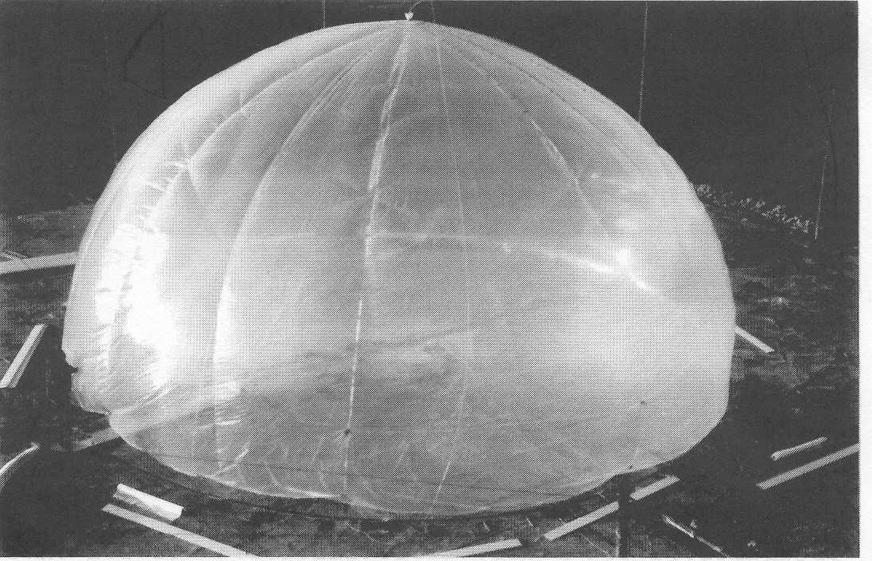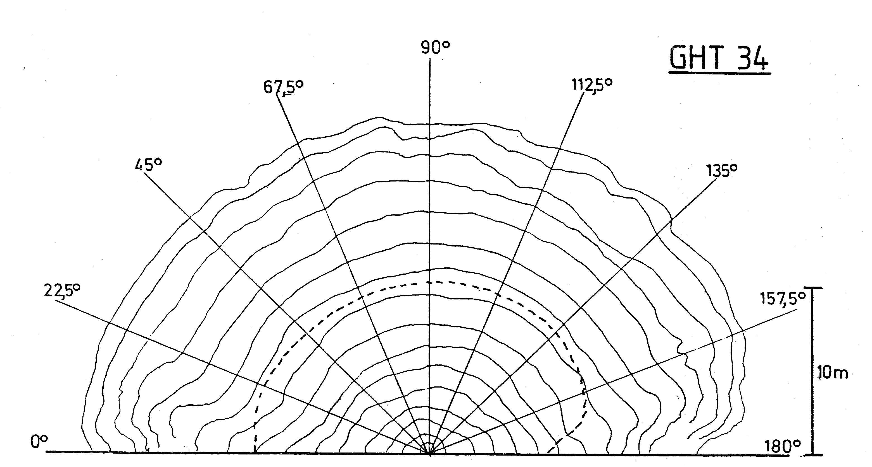  10 m radius hemisphere with hydrogen-air mixture. Flame front contours with time.
What phenomena were studied | Flame front propagation and pressure generation after point ignition of initially quiescent mixture.
What phenomena/effects can be validated | Flame propagation dynamics in open atmosphere, pressure wave generation and propagation.
Instrumentation | Pressure transducers, video cameras to obtain flame contours.
Test variables | -
Data description / Data completeness | Snapshots of flame contours up to 20 m and average flame front radius in time, pressure-time transients at 2, 2.4, 5, 6.5, 8, 18, 25, 35, 60, 80 m from the ignition point.
Data availability | Experiment performed by HySafe partner (FhG-ICT)
Source of data / Reference | 1. Schneider H., Pförtner H. PNP-Sichcrheitssofortprogramm, Prozebgasfreisetzung-Explosion in der gasfabrik und auswirkungen von Druckwellen auf das Containment. Dezember 1983.  2. Becker T., Ebert F., Vergleich zwischen experiment und theorie der explosion grober, freier gaswolken. Chem.-Ing.-Tech., V.57, N.1, pp.42-45, 1985
Why were chosen | Largest ever experiment on hydrogen-air deflagration in open atmosphere.
Relevance to the project purposes | One of the possible scenarios in practice is hydrogen-air deflagration in open atmosphere.

Experiment ID | Balloon tests (hemispherical shape)
Short description | A series of tests has been performed with nearly stoichiometric H₂/air mixtures, enclosed in different sized hemispherical balloons with volumina of between 7.5 m³ and 2094 m³ (corresponding radii 1.5 m and 10 m), lying on the ground and being ignited by means of exploding wire or pyrotechnic ignitor with ignition energies of between 10 J and 1000 J. Flame speeds and pressure/time histories has been measured.
What phenomena were studied | At the beginning of gas explosion research the question arised, if there is a flame acceleration within initially quiescent, premixed and unconfined fuel/air mixtures because of instabilities in flame propagation (so-called flame induced turbulence) and if so, which would be the limit of the flame speed and corresponding overpressure for very large clouds.
What phenomena/effects can be validated | For stoichiometric hydrogen-air-mixrures for example, the flame speed limit is 125 m/s, corresponding to a peak overpressure of 130 mbars.
Instrumentation | Measurements included up to 12 piezoresistive pressure transducers, and up to 4 high speed cameras (side view and top view).
Test variables | Balloon radius: 1.5m to 10m
Data description / Data completeness | All pressure-time histories as hard copies; 16mm films; flame distance-time-diagrams as hardcopies
Data availability | Publicly accessible
Source of data / Reference | Fh-ICT-report (Dec.1983): Ballonversuche zur Untersuchung der Deflagration von Wasserstoff/Luft-Gemischen
Why were chosen | Basic investigation on relation: cloud size/ flame speed
Relevance to the project purposes | Phenomena in very large clouds

Experiment ID | IA1-IA5 (5 tests)
Short description | Partial confinement – simulating a “lane” – consisting of 2 parallel walls at a distance of 3 m with a length of 12 m and a height of 3 m. The whole volume has been filled with H₂/air mixture, enclosed within a very thin PE-foil. At one of the front sides of this lane a container (length 3m, cross section 1.5x1.5 m²) with a variable opening (vent opening ratios 0.1 and 0.3, i.e. ratio of areas: opening area/front side area of container) has been installed, containing the same mixture as in the lane. The mixture has been ignited at the rear side of the container. The flame jet emerging out of the container ignites the mixture within the lane.
What phenomena were studied | The background for doing this type of tests has been the idea, that the phenomenon of DDT in geometrically similar arrangements could be scaled by means of the detonation cell width. Within a test set-up similar to that described above, but with dimensions being a factor of 3 smaller, Battelle/Germany succeeded in getting DDT for stoichiometric H₂/air mixtures, but no DDT with other concentrations. If it is assumed that the effect can be scaled linearly with the detonation cell size, then in a similar test set-up with dimensions, which were 3 times larger, the limit for DDT (go/no go) should be in mixtures with H₂ content of 20.5 vol% according to the U-shaped relation between detonation cell size and fuel concentration or equivalence ratio.
What phenomena/effects can be validated | Geometrically similar facilities of the type investigated here, can be linearly scaled with detonation cell size with respect to DDT.
Instrumentation | Gaschromatographic analysis of mixture homogeneity. Accuracy of H₂ : ± 0.3 vol%. 2 piezoresistive pressure transducers within container. 2 sets of pressure transducers within the lane floor (8 piezoresistive and 8 piezoelectric transducers). 3 high speed cameras (2 with view from above, 1 with horizontal view into the lane).
Test variables | Vent opening ratio of container front side: 0.1 and 0.3; hydrogen concentration (vol%): 20.2 – 22.5
Data description / Data completeness | Film recordings (16 mm) available; pressure/time histories as hardcopies
Data availability | Publicly accessible
Source of data / Reference | Fh-ICT-report (Oct.1984): Versuche zur Freistrahlzündung partiell verdämmter Wasserstoff/Luft- Gemische im Hinblick auf die Skalierbarkeit des Übergangs Deflagration/Detonation
Why were chosen | Of relevance for realistic scenario: ignition in closed room with venting (garage for example) and subsequent flame jet ignition of partially confined cloud outside (some sort of a lane)
Relevance to the project purposes | Important for the establishment of criteria for DDT, especially scaling of DDT- phenomena

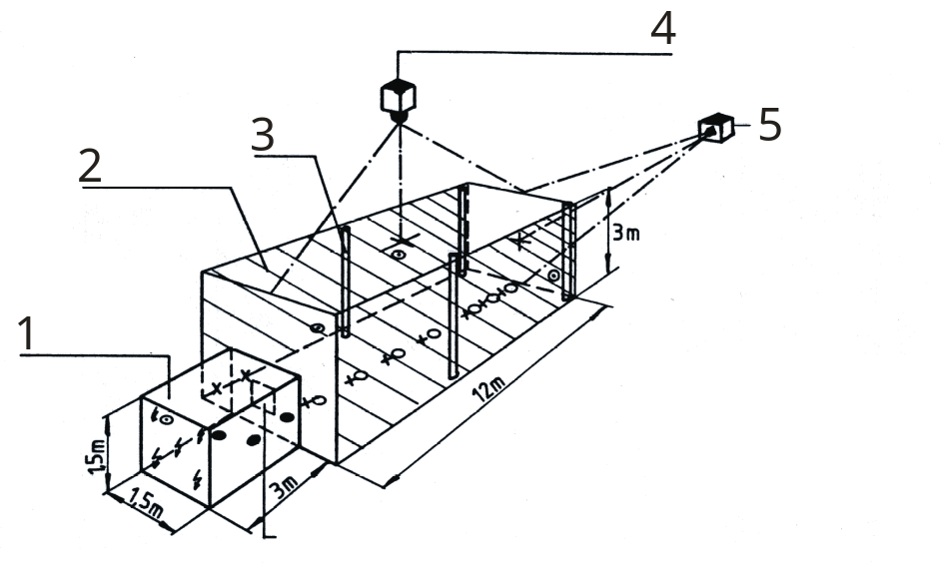

1: container with opening in front side x,o: pressure transducers
2: partially confined hydrogen air mixture •: photo transistors
3: tube Θ: samples taken for measurement
4: Hycam and Locam camera of H₂-concentration
5: hycam camera

Experiment ID | GHT35-GHT47 (11 tests)
Short description | Partial confinement – simulating a “lane” – consisting of 2 parallel walls at a distance of 3m with a length of 10m and a height of 3m. At one end of the lane an additional wall has been installed. The whole volume has been filled with H₂/air mixture, enclosed within a very thin PE-foil, with concentrations between 37 and 41 vol% H₂. The mixture has been ignited in the centre of the closed end or open end. For the generation of turbulence a fan with dia. 1.25 m and max. efficiency of 24 000 m³/h has been used at the closed end of the lane. The tests have been performed with 50%, 75%, 90% and 100% of this maximum value.
What phenomena were studied | Flame acceleration under conditions of partial confinement and turbulence
What phenomena/effects can be validated | Correlation between flame speed and turbulence. Observation of DDT
Instrumentation | Gas chromatographic analysis of mixture homogeneity. 2 types of pressure transducers: 6 piezoresistive and 6 piezoelectric sensors, installed within the lane floor. 3 high speed cameras (2 with view from above, 1 with horizontal view into the lane). Measurement of cold flow field within the air-filled PE-enclosure by means of hot wire anemometer for situation with 100% fan speed .
Test variables | Turbulence intensity; Degree of partial confinement; Location of ignition
Data description / Data completeness | Film recordings (16 mm) available; pressure/time histories as hardcopies; turbulence data
Data availability | Publicly accessible
Source of data / Reference | Fh-ICT-report (July 1984): Explosion von Wasserstoff/Luft-Gemischen unter teilverdämmten Bedingungen und unter dem Einfluß einer turbulenten Strömung.
Why were chosen | Realistic scenario
Relevance to the project purposes | Correlation between turbulence and flame speed; criteria for DDT

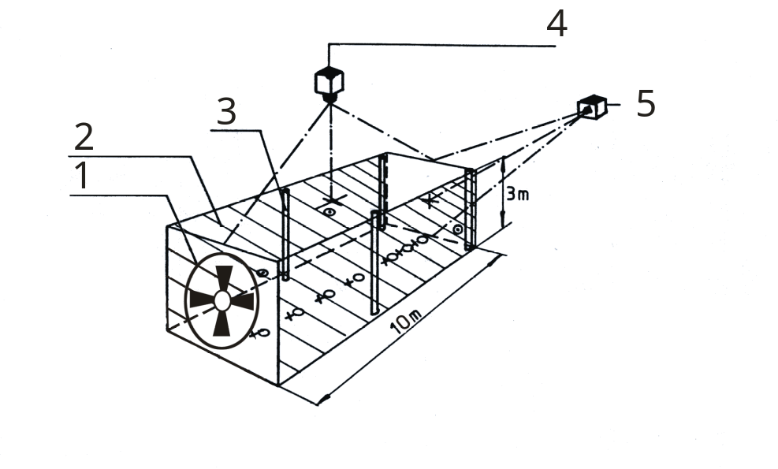

1: fan
2: partially confined hydrogen/air mixture
3: tube
4: Hycam- and Locam cameras
5: Hycam camera
X, Ο: pressure transducers
Θ: sample taken for hydrogen-concentration measurement

Name/test-ID | LH2-Tank rupture tests
Short description | Tanks for cars with liquid hydrogen up to 70 l were ruptured at the top and the instantaneous jet ignited: high speed cinematography, pressure measurements and radiation measurements at distances of about 20-22 m
Describe means of mitigation | .
Describe instrumentation | Transient pressure time histories have been recorded at various positions. 11 Kistler piezoelectric pressure transducers  High speed cameras up to 2 000 frames /s  Spectroscopy: UV: Diode array, 300-330nm, 0.1 nm, scan 10 ms,  Filter wheel continuously 1.2-2.4 µm, scan 10 ms  Filter wheel continuously 2.5-14 µm, scan 10 ms  2-Colour Pyrometer Si/Ge-Sandwich, 1MHz
Available results | Tables, graphs of Pressure, radiation intensity, temperatures depending on time  Films of the events
Evaluation parameters | Quantitative measurement of radiation in correlation to pressure and time
Data availability | From BMW and Fraunhofer ICT
Source of data | Results: Report: EQHHPP –Tankberstversuche,Pfinztal-Berghausen Mai 1993  Eckl, W. Eisenreich, N. ; Herrmann, M.M. ; Weindel, M.: Emission of radiation from liquefied hydrogen explosions, Chem.-Ing.Tech. (1995) 67 (8), 1015-17
Reason for choosing this dataset | Detailed quantitative spectroscopic and pyrometrical measurements of jet explosions from bursting tanks at real scale
Quality and relevance of data | Repeated tests with varying configurations and mass of hydrogen.  Impurities mix into water band radiation a continuous radiation
Add additional explanations, pictures or comments

Explosion
20-22 m
Spectrometers
UV-IR
High speed camera
Pressure transducer
70 l LH2
Rupture

Name/test-ID | Safety tests on worst case scenarios
Short description | Gas explosions, e.g. hydrogen-air, under defined conditions (gas concentration, ignition…) on industrial and commercial facilities and devices (e.g. fuel cell vehicles, lasers, hydrogen storage systems…)
Describe means of mitigation | Representation and reconstruction of hazardous scenarios in order to carry out damage effects to minimize potential risks and to verify constructive mitigation techniques.
Describe instrumentation | - Transient multi channel pressure measurement based on piezoelectric and resistive pressure transducers / amplifiers with high time resolution  - Multi channel Temperature measurements based on thermocouples  - High-speed spectroscopy (near infrared and ultraviolet and visible range)  - Background oriented schlieren technique (BOS)– visualization of expanding hot gas clouds and pressure waves with high time resolution  - Visualisation and documentation with high speed digital imaging systems
Available results | All data is available in electronic format for each test.
Evaluation parameters | Highly time resolved pressure and temperature histories as well as the optical visualization techniques are suited to evaluate risks and to develop and optimize constructive mitigation techniques
Data availability | The datasets are owned by ICT and our project partners.
Source of data | Confidential ICT reports
Reason for choosing this dataset | -
Quality and relevance of data | -
Add additional explanations, pictures or comments | -

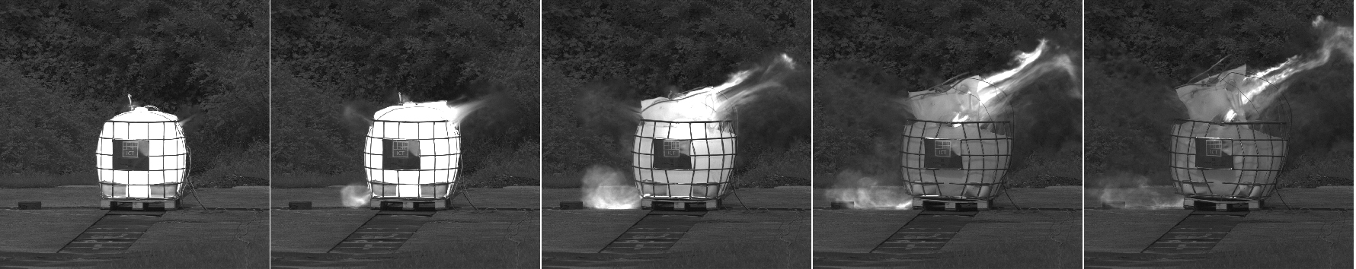

The example shows a hydrogen air explosion inside a commercial 1000 liter plastics container

Experiment ID | GexCon 3D-Corner Test 02, Test 22 and Test 66
Short description | Explosion experiments with hydrogen were carried out in a 50 litre 3D-array of pipes (l = 0.368 m, diameter and pitch varies, see figure below). Ignition in closed corner. Gas concentrations ER=0.94 (test 02), 1.01 (test 22) and 0.97 (test 66). Thin polyethylene sheets keep gas inside array prior to ignition.
What phenomena were studied | Effect of blockage ratio for 3D flame propagation.
What phenomena/effects can be validated | Ability of prediction tool to take into account flame interaction with geometries of varying complexity.
Instrumentation | Pressure measurement in 4 locations (see sketch below), at positions from corner (mm): Mon1=(1, 43, 43), Mon2=(1,175, 315), Mon3=(265,1,11) and Mon4=(350, 350, 1).
Test variables | Cylinder diameter and pitch (in other tests more variables are varied)
Data description / Data completeness | All pressure in digital form
Data availability | Results owned by GexCon and sponsors Norsk Hydro and Statoil
Source of data / Reference | Technical Report: GexCon-03-F46201-2-rev01 (confidential)
Why were chosen | Tests illustrates well the significance of repeated obstacles to 3D flame acceleration
Relevance to the project purposes | Should be highly relevant (same tests with nitrogen dilution will be applied in Mitigation workpackage).

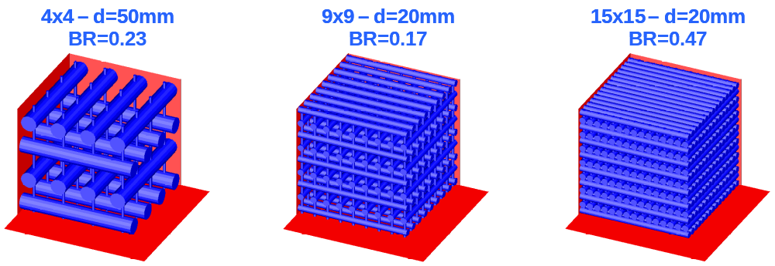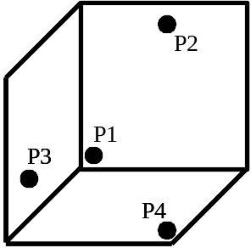

Experiment ID | GexCon MOGELEG channel (exact Test ID will be provided later):  Empty channel (ER=0.75, 1.00, 1.25), Two baffles (ER=1.00)
Short description | Vented hydrogen explosions in a 1.44m x 0.30m x 0.30m channel on a table without or with 2 baffles (B2, B4) of 5 cm height and full (30 cm width) at location 0.48m and 0.96m from inner wall. Ignition centrally at the inner end. Concentration variation provided for the empty channel.
What phenomena were studied | Venting, external explosion, effect of baffles on flame acceleration, effect of variation in H₂ concentration.
What phenomena/effects can be validated | Ability of prediction tool to take into account flame acceleration across baffles, concentration variations, external explosion effects in connection to venting.
Instrumentation | Pressure measurement in 4 locations (see sketch below), 3 at rear wall P1=(0.13m,0.299m,0.06m), P2=(0.61m,0.299m,0.06m), P3=(1.095m,0.299m,0.06m) and one outside vent P4=(1.68m,0.21m,0.001m). Ionisation gap measurements were also carried out, but these seemed less reliable.
Test variables | Geometry is varied (zero or two baffles) and gas concentration is varied (empty channel)
Data description / Data completeness | All pressure result in digital form
Data availability | Results owned by GexCon and sponsors Norsk Hydro and Statoil
Source of data / Reference | Technical Report: GexCon-03-F46201-2-rev01 (confidential)
Why were chosen | Tests show the effect of external explosion, variation in gas concentration and geometry (baffles)
Relevance to the project purposes | Should be highly relevant, will act as reference tests for mitigation SBEP tests with nitrogen dilution.

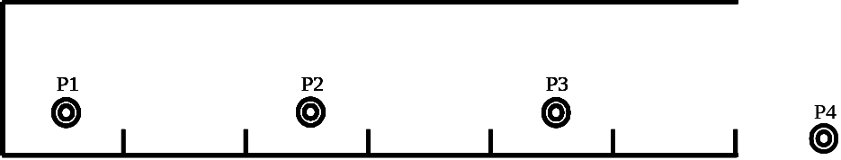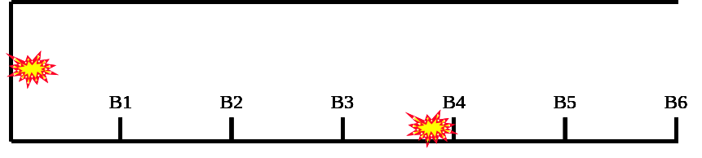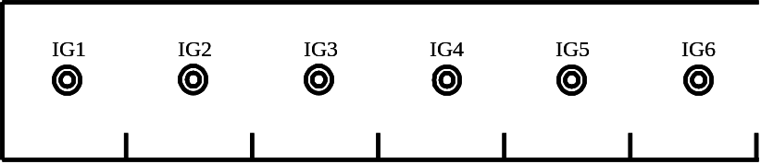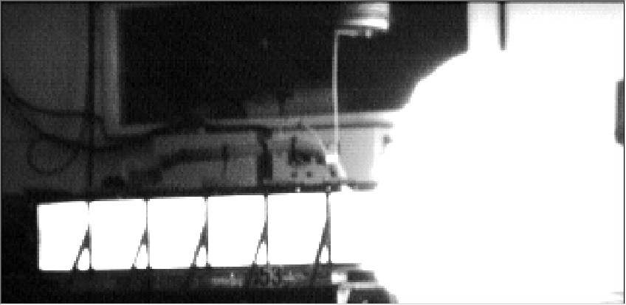

Experiment ID | FIKE Experiments in pipelines of diameter 6”/15m (6 concentrations), 10”/25m and 16”/40m pipes
Short description | Explosion experiments with hydrogen in straight pipes of 3 different diameters (All with L/D = 98) were carried out, for the 6”/15m pipe 6 different gas concentrations were applied.
What phenomena were studied | Flame acceleration in straight pipes, DDT transition distance if applicable
What phenomena/effects can be validated | Flame acceleration in long pipes, DDT
Instrumentation | 12 flame detectors are mounted, as well as 3 pressure transducers
Test variables | Dimension of pipe (6”, 10” and 16”) L/D=98, and H₂ concentration (10%, 20%, 25%, 30%, 35%, 40%, 50%)
Data description / Data completeness | Pressure result in digital form, flame arrivals will be tabulated.
Data availability | Results are owned and will be made available by Fike Corporation, USA
Source of data / Reference | Chatrathi, K., Going, J.E. and Grandestaff, B “Flame propagation in industrial scale piping”, Process Safety Progress, Vol. 20, No.4, pp 286-294, December 2001 (Data and details not found in paper will be provided by John E. Going, Fike.
Why were chosen | Tests illustrates flame acceleration in pipes.
Relevance to the project purposes | Hydrogen flame acceleration in industrial pipes is a common hazard scenario in industry.

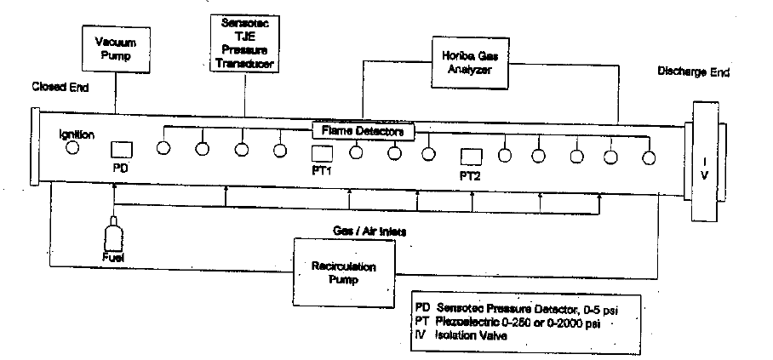

Experiment ID | HYCOM-MC043
Short description | Combustion experiments have been carried out in obstructed tube of 174 mm i.d. and 12.1 m long (DRIVER facility). Repeatable obstacles at distances equal to i.d.  The experimental tube was divided in two equal parts by thin polyethylene membrane (1 μm) with different blockage ratios (BR1 and BR2) and hydrogen concentrations in air (C1 and C2). Critical pressure for membrane breaking was found to be about 5 Torr. Hydrogen concentration/Obstruction (BR) for Part 1: 13% / 0.6, for Part 2: 10% / 0.3. Ignition at the tube end in Part 1.
What phenomena were studied | Effect of concentration gradients (transient of accelerated flame from rich to lean mixture)  Effect of blockage ratio changes (transient of accelerated flame to the area with lower degree of obstruction)
What phenomena/effects can be validated | Flame acceleration in the presence of nonuniform initial conditions
Instrumentation | Three types of pressure transducers (1) piezoresistive transducers D06 (one-membrane type, frequency 1 kHz), (2) piezoresistive transducers PPD1.6 (two-membrane type, frequency 100 kHz), and (3) piezoelectric transducers PCB-H113A (frequency 100 kHz).  Collimated germanium photodiodes (up to 23) for measurement of the time-of arrival of the flame front. Time resolution of 10 μs. The photodiodes were not calibrated, and they provided flame radiation intensity qualitatively.
Test variables | Blockage ratio, hydrogen concentration
Data description / Data completeness | All pressure and photo-diode recordings in digital form
Data availability | Publicly accessible
Source of data / Reference | Technical Report: EU Project HYCOM, 2004 (to be published)
Why were chosen | Very well instrumented, complete description, by the moment no similar results elsewhere are available
Relevance to the project purposes | Can address separate phenomena, which are of primary interest for the project purposes.

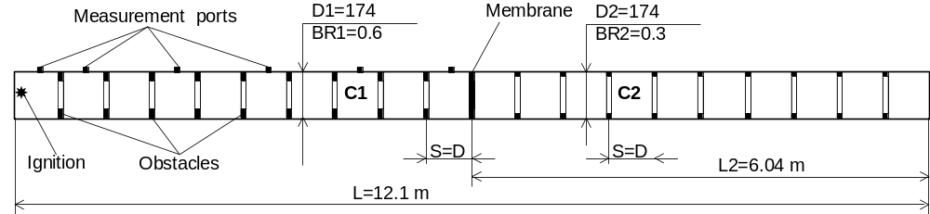

Experiment ID | HYCOM-HC020
Short description | Combustion experiments have been carried out in nonuniform obstructed tube of 12.4 m long combined of two parts with diameter of 174 and 520 mm i.d. (Configuration 3). Obstacles spaced by tube diameter. Diameter / Obstruction (BR) for Part 1: 174 mm / 0.6, for Part 2: 520 mm / 0.3.  Combustion of uniform test mixture with 10% of H2 in air was investigated. Ignition point is I2 (Part 2).
What phenomena were studied | Effect of tube diameter change (flame propagating from higher to less tube size)  Effect of blockage ratio changes (flame propagating to the area with more degree of obstruction)
What phenomena/effects can be validated | Effect of pre-compression in nonuniform geometry
Instrumentation | Measurements include 6 piezoresistive transducers and 16 collimated germanium photodiodes. Time resolution of 10 μs. The photodiodes were not calibrated, and they provided flame radiation intensity qualitatively.
Test variables | Tube diameter, blockage ratio
Data description / Data completeness | All pressure and photo-diode recordings in digital form
Data availability | Publicly accessible
Source of data / Reference | Kuznetsov M.S, Alekseev V.I., Yankin Yu.G., Dorofeev S.B. Flame acceleration in a tube with variable cross-section. J. Phys. IV France, vol. 12, pp 317-324 (2002)
Why were chosen | Very well instrumented, complete description, by the moment no similar results elsewhere are available
Relevance to the project purposes | Can address separate phenomena, which are of primary interest for the project purposes

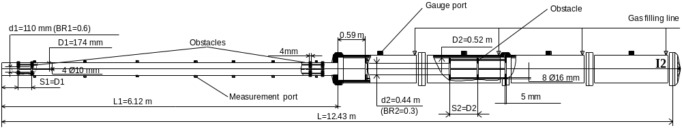

Experiment ID | HYCOM-HC027
Short description | Combustion experiments have been carried out in nonuniform obstructed tube of 12.4 m long combined of two parts with diameter of 174 and 520 mm i.d. (Configuration 3). Obstacles spaced by tube diameter. Diameter / Obstruction (BR) for Part 1: 174 mm / 0.3, for Part 2: 520 mm / 0.6. Sonic combustion of uniform test mixture with 13% of H2 in air was investigated Ignition point is I1 (Part 1).
What phenomena were studied | Effect of tube diameter change (flame propagating from less to higher tube size)  Effect of blockage ratio changes (flame propagating to the area with lower degree of obstruction)
What phenomena/effects can be validated | Flame propagation in the presence of nonuniform geometry.
Instrumentation | Measurements include 6 piezoresistive transducers and 16 collimated germanium photodiodes. Time resolution of 10 μs. The photodiodes were not calibrated, and they provided flame radiation intensity qualitatively.
Test variables | Tube diameter, blockage ratio
Data description / Data completeness | All pressure and photo-diode recordings in digital form
Data availability | Publicly accessible
Source of data / Reference | Technical Report: EU Project HYCOM, 2004 (to be published)
Why were chosen | Very well instrumented, complete description, by the moment no similar results elsewhere are available
Relevance to the project purposes | Can address separate phenomena, which are of primary interest for the project purposes

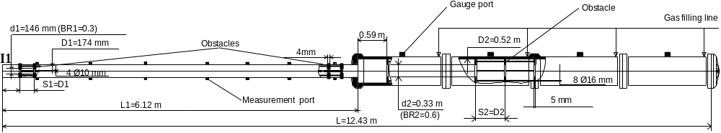

Experiment ID | HYCOM-MC003
Short description | Test 1 of 3 (MC003, MC012, R0489_09). Combustion experiments have been carried out in obstructed tube of 174 mm i.d. and 12.2 m long (DRIVER facility). Repeatable obstacles with blockage ratio BR=0.6 at distances equal to i.d. Hydrogen/air mixture with concentration of 10% H2 was tested.
What phenomena were studied | Flame acceleration in the presence of obstructed channel
What phenomena/effects can be validated | Unstable subsonic flame with local quenching
Instrumentation | Three types of pressure transducers (1) piezoresistive transducers D06 (one-membrane type, frequency 1 kHz), (2) piezoresistive transducers PPD1.6 (two-membrane type, frequency 100 kHz), and (3) piezoelectric transducers PCB-H113A (frequency 100 kHz).  Collimated germanium photodiodes (up to 23) for measurement of the time-of arrival of the flame front. Time resolution of 10 μs. The photodiodes were not calibrated, and they provided flame radiation intensity qualitatively.
Test variables | Hydrogen concentration
Data description / Data completeness | All pressure and photo-diode recordings in digital form
Data availability | Publicly accessible
Source of data / Reference | Technical Report: EU Project HYCOM, 2004 (to be published)
Why were chosen | Very well instrumented, complete description
Relevance to the project purposes | Series of three experiments can address effect of mixture composition on flame propagation in obstructed geometry. Has primary importance for code validation.

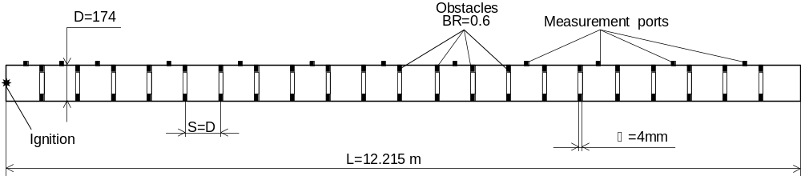

Experiment ID | HYCOM-MC012
Short description | Test 2 of 3 (MC003, MC012, R0489_09). Combustion experiments have been carried out in obstructed tube of 174 mm i.d. and 12.2 m long (DRIVER facility). Repeatable obstacles with blockage ratio BR=0.6 at distances equal to i.d. Hydrogen/air mixture with concentration of 13% H2 was tested.
What phenomena were studied | Flame acceleration in the presence of obstructed channel
What phenomena/effects can be validated | Steady-state sonic flame
Instrumentation | Three types of pressure transducers (1) piezoresistive transducers D06 (one-membrane type, frequency 1 kHz), (2) piezoresistive transducers PPD1.6 (two-membrane type, frequency 100 kHz), and (3) piezoelectric transducers PCB-H113A (frequency 100 kHz).  Collimated germanium photodiodes (up to 23) for measurement of the time-of arrival of the flame front. Time resolution of 10 μs. The photodiodes were not calibrated, and they provided flame radiation intensity qualitatively.
Test variables | Hydrogen concentration
Data description / Data completeness | All pressure and photo-diode recordings in digital form
Data availability | Publicly accessible
Source of data / Reference | Technical Report: EU Project HYCOM, 2004 (to be published)
Why were chosen | Very well instrumented, complete description
Relevance to the project purposes | Series of three experiments can address effect of mixture composition on flame propagation in obstructed geometry. Has primary importance for code validation.

Experiment ID | FZK-R0498_09
Short description | Test 3 of 3 (MC003, MC012, R0489_09). Combustion experiments have been carried out in obstructed tube of 350 mm i.d. and 12 m long. Repeatable obstacles with blockage ratio BR=0.3 at distances equal to i.d. Hydrogen/air mixture with concentration of 15% H2 was tested.
What phenomena were studied | Flame acceleration up to detonation transition
What phenomena/effects can be validated | Deflagration-to-detonation transition, steady-state detonation propagation in obstructed channel
Instrumentation | Measurements include 24 piezoelectric transducers, 24 collimated photodiodes.
Test variables | Hydrogen concentration, tube diameter
Data description / Data completeness | All pressure and photo-diode recordings in digital form
Data availability | Publicly accessible
Source of data / Reference | FZK Technical Report.
Why were chosen | Very well instrumented, complete description
Relevance to the project purposes | Series of three experiments can address effect of mixture composition on flame propagation in obstructed geometry. Has primary importance for code validation.

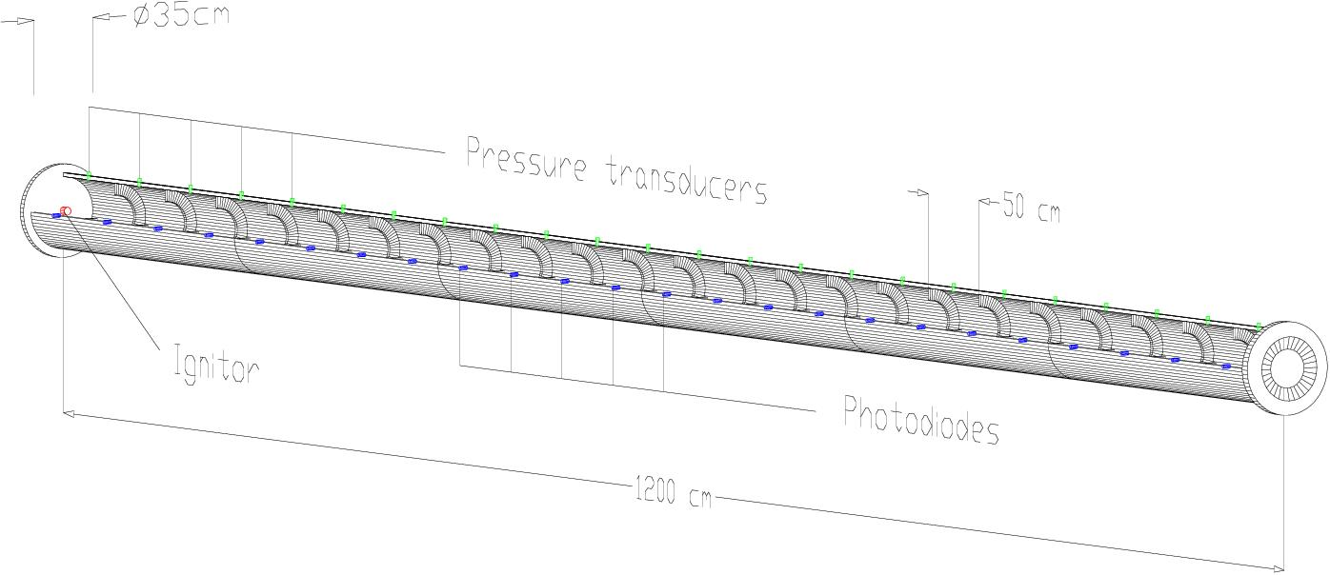

Experiment ID | HYCOM-HYC01
Short description | Test 1st of 3 (HYC01, HYC12, HYC14). Combustion experiments have been carried out in large scale multi-compartment geometry consisted of curved channel (2.3x2.5 m cross-section and 15.5 m length) and canyon (6.3x2.5x16.4 m). Four repeatable obstacles with blockage ratio BR=0.3 installed in the channel and two obstacles in bottom part of canyon. Uniform hydrogen/air mixture with concentration of 10% H2 was tested. Ignition in the channel (I1).
What phenomena were studied | Flame acceleration in the non-uniform multi-compartment geometry
What phenomena/effects can be validated | Unstable subsonic flame
Instrumentation | Measurements include 16 piezoresistive and 16 piezoelectric transducers, 45 collimated germanium photodiodes and 10 heat-flux gauges.
Test variables | Hydrogen concentration, compartment geometry, ignition point
Data description / Data completeness | All pressure and photo-diode recordings in digital form
Data availability | Publicly accessible
Source of data / Reference | Technical Report: EU Project HYCOM, 2004 (to be published)
Why were chosen | Very well instrumented, complete description, by the moment no similar results elsewhere are available
Relevance to the project purposes | Series of three experiments can be used as integral experiments for the code validation on combustion process development in complex geometries on scales relevant to industrial.

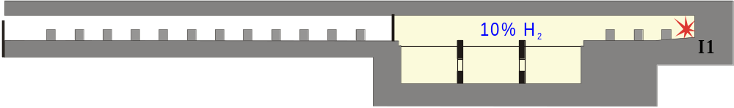

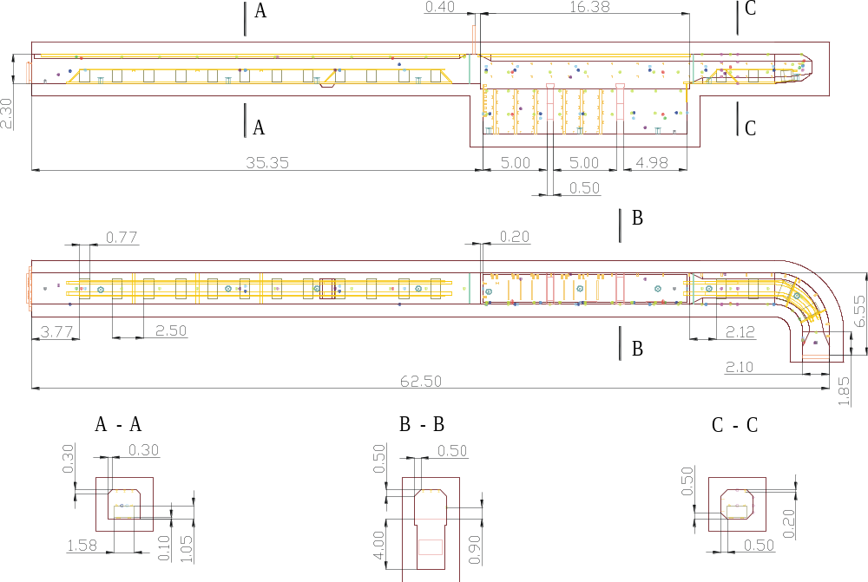

Experiment ID | HYCOM-HYC12
Short description | Test 2nd of 3 (HYC01, HYC12, HYC14). Combustion experiments have been carried out in large scale multi-compartment geometry consisted of curved channel (2.3x2.5 m cross-section and 15.5 m length) and canyon (6.3x2.5x16.4 m). Four repeatable obstacles with blockage ratio BR=0.3 installed in the channel. Canyon has been divided in four separate rooms connected with orifices. Uniform hydrogen/air mixture with concentration of 11.5% H2 was tested. Ignition in the channel (I1).
What phenomena were studied | Flame acceleration in the non-uniform multi-compartment geometry
What phenomena/effects can be validated | Unstable subsonic flame
Instrumentation | Measurements include 16 piezoresistive and 16 piezoelectric transducers, 45 collimated germanium photodiodes and 10 heat-flux gauges.
Test variables | Hydrogen concentration, compartment geometry, ignition point
Data description / Data completeness | All pressure and photo-diode recordings in digital form
Data availability | Publicly accessible
Source of data / Reference | Technical Report: EU Project HYCOM, 2004 (to be published)
Why were chosen | Very well instrumented, complete description, by the moment no similar results elsewhere are available
Relevance to the project purposes | Series of three experiments can be used as integral experiments for the code validation on combustion process development in complex geometries on scales relevant to industrial.

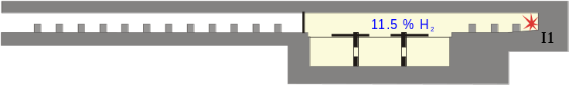

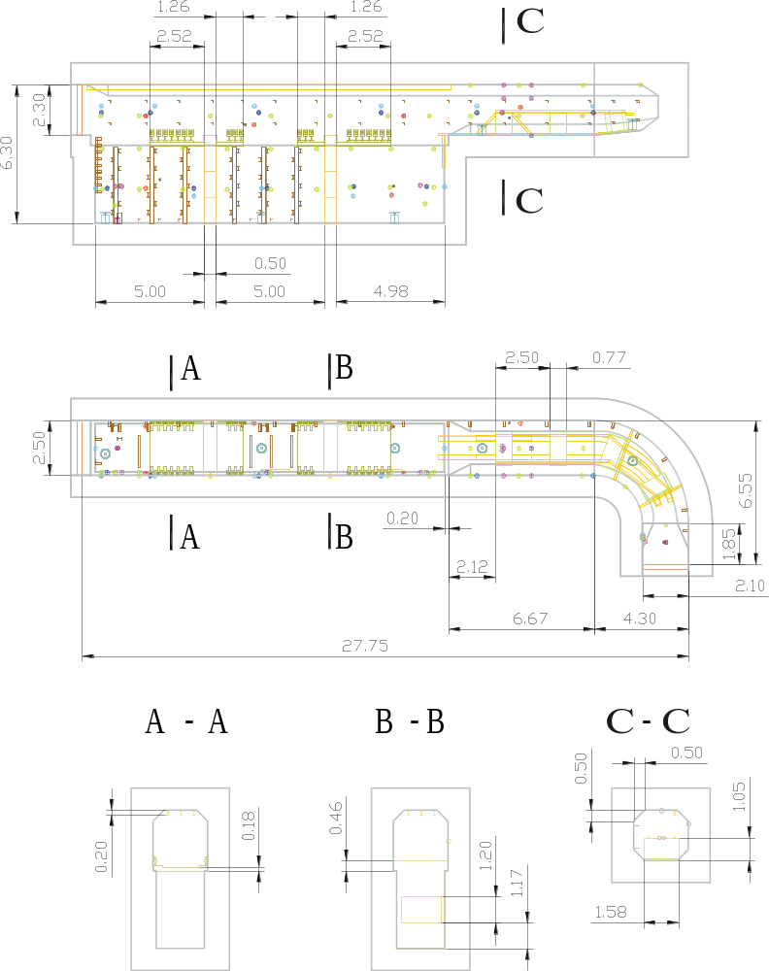

Experiment ID | HYCOM-HYC14
Short description | Test 1st of 3 (HYC01, HYC12, HYC14). Combustion experiments have been carried out in large scale multi-compartment geometry consisted of curved channel (2.3x2.5 m cross-section and 15.5 m length) and canyon (6.3x2.5x16.4 m). Four repeatable obstacles with blockage ratio BR=0.3 installed in the channel. Canyon has been divided in four separate rooms connected with orifices. Uniform hydrogen/air mixture with concentration of 11.5% H2 was tested. Ignition in the channel (I4).
What phenomena were studied | Flame acceleration in the non-uniform multi-compartment geometry
What phenomena/effects can be validated | Unstable subsonic flame
Instrumentation | Measurements include 16 piezoresistive and 16 piezoelectric transducers, 45 collimated germanium photodiodes and 10 heat-flux gauges.
Test variables | Hydrogen concentration, compartment geometry, ignition point
Data description / Data completeness | All pressure and photo-diode recordings in digital form
Data availability | Publicly accessible
Source of data / Reference | Technical Report: EU Project HYCOM, 2004 (to be published)
Why were chosen | Very well instrumented, complete description, by the moment no similar results elsewhere are available
Relevance to the project purposes | Series of three experiments can be used as integral experiments for the code validation on combustion process development in complex geometries on scales relevant to industrial.



Experiment ID | HSL hydrogen detonation trials
Short description | Stoichiometric volumes of hydrogen/air mixtures were forced to detonation by an explosive charge. Volumes of 5, 10 and 20 m3 were detonated.  The hydrogen/air mixtures were enclosed in a plastic-covered, wooden-framed structure, which also contained a limited array of instrumentation and a fan for mixing the gases.  The explosive charge was supported from the roof of the structure, so as to be suspended in the centre of the cubic frame.
What phenomena were studied | The over-pressures generated within the frame were measured.  The sound levels generated at a range of positions were recorded.
What phenomena/effects can be validated | Sound levels/over-pressures at a range of distances can be determined.
Instrumentation | Oxygen depletion cells were used to determine the gas concentration within the frame.  Kistler pressure transducers were used to measure pressures within and close to the structure at the point of detonation.  Measure and hold sound level meters were used to record the maximum sound level at a number of locations up to 500 m from the test site (The sound level can be used to determine the local over-pressure.
Test variables | Volume of gas detonated
Data description / Data completeness | All pressure data in digital format. Single point readings of maximum sound levels and gas concentration readings.
Data availability | Restricted to HSL currently.
Source of data / Reference | Technical Report: HSL PS/04/07
Why were chosen | No similar results elsewhere are available
Relevance to the project purposes | Dispersion data are valuable for developing and verifying dispersion models.

Experiment ID | HSL Ignited, congested, Jet releases
Short description | Medium pressure jets of hydrogen (25-150) were released horizontally through orifice sizes of 1 – 12 mm.  The jet was directed into a congested region. The congestion rig comprised a 1m³ structure containing vertical arrays of 25mm diameter cylindrical objects. The structure was confined by a solid floor, ceiling and back wall.  The 25mm rods were held in a number of grids. Each grid comprised 10 rods and the congestion structure could hold 10 grids.  The congestion causes the turbulence within the released gas cloud to be increased.  The jets were ignited and the over-pressure produced in the congestion rig was measured.
What phenomena were studied | The over-pressures generated within the frame were measured.  The sound levels generated at a range of positions were recorded.
What phenomena/effects can be validated | Sound levels/over-pressures at a range of distances can be determined.
Instrumentation | The jet release conditions were measured using pressure transducers and a thermocouple located at the release orifice.  Kistler pressure transducers were used to measure pressures within and close to the structure at the point of ignition; hydrophone pressure transducers were used to measure the over-pressure at increasing distances from the congestion rig.  Measure and hold sound level meters were used to record the maximum sound level at a number of locations up to 300 m from the test site (The sound level can be used to determine the local over-pressure.
Test variables | Stand-off distance of congestion rig, number of gates, gas pressure, orifice size, release duration.
Data description / Data completeness | All pressure data in digital format. Single point readings of maximum sound levels and gas concentration readings.
Data availability | Restricted to HSL and Shell Global Solutions currently.
Source of data / Reference | Technical Report: HSL PS/02/07
Why were chosen | No similar results elsewhere are available
Relevance to the project purposes | Provide information relating to hazards from ignition of jet releases in congested areas..

Experiment ID | CVE, Chambre View Explosion
Short description | Vented explosion experiments have been carried out in a cubic structure made of steel section bars with an internal volume of 27 m³. The CVE’s roof and one side face are entirely covered with panes of glass in order to see the behaviour of the explosion; all the other faces are covered with steel panels having different functions: the bottom and one side faces are entirely made of steel strengthened panels which are not removable, while the other two lateral faces, on opposite side, are the test vent and the safety vent respectively (see figure 1).  The design internal overpressure’s value is 200 mbar (20 kPa), and so the opening of the security vent was settled at 150 mbar (15 kPa).
What phenomena were studied | Effect of hydrogen stratification in the chamber (transient of pressure waves from rich to lean mixture)  Effect of the vent area size on the internal and external pressure waves  Flame propagation’s transient behaviour
What phenomena/effects can be validated | Time development of internal overpressure waves generated by the hydrogen-air atmosphere explosions both with uniform and non-uniform initial condition  Time development of external overpressure waves generated after the opening of the test vent area both with uniform and non-uniform initial condition  Validation of 3D-codes related to gas deflagration behaviour
Instrumentation
  INSTRUMENT TYPE | N. OF ITEMS | MEASURING PRINCIPLE | RANGE | OUTPUT | MAXIMUM ERROR
  Flow meter | 1 | Turbine | 6-100 Nm3/h | 0.4-7 Hz | 1.5 % of the range
  Flow meter | 1 | variable area | 0-19 Nl/sec | 4-20 mA | 0.8 % of the range
  Concentration analyzer | 6 | Thermal conductibility | 0-20 %vol. | 4-20 mA | 3 % of the range
  Pressure transducer | 3 | Piezoelectric | 0-5 bar | 4-20 mA | 0.3 % of the range
  Digital camera | 2 |  | 25 fps
Test variables | Hydrogen concentration  Vent area  Number and location of ignitors
Data description / Data completeness | Transient concentration measurements and recordings in digital form during hydrogen’s introduction in the chamber  Pressure waves measurements and recordings in digital form during explosions  Transient flame shape digital camera’s recordings (two point of view: upper and lateral) during explosions
Data availability | No public accessible
Source of data / Reference | Internal documents
Level of restriction | Confidential
Why were chosen
Relevance to the project purposes | Can address separate phenomena, which is of great importance for the project purposes and can be useful also for studying the safety of other hydrogen applications: by introducing an element (H₂ sensor, fuel cell and so on) in the CVE we can measure hydrogen leakages, pressure waves generated in case of explosion, etc.

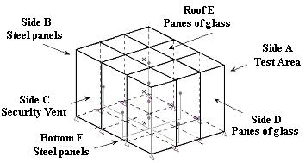

CVE’s description; (O) ignition points and (X) concentration’s measurement points

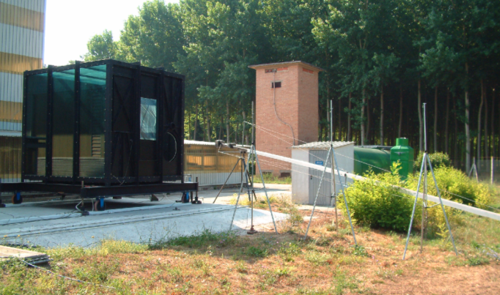

CVE’s photograph: Side A, test area, and Side D, face with panes of glass

Experiment ID | Shell Hydrogen Refuelling Station (HRS-1)
Short description | A mock-up of a Hydrogen Refuelling Station, which includes a brick wall, two dispensers and simplified steel structure representing a vehicle, was designed; Figs. 1 and 2 show the refuelling station from two angles.  Polythene film is wrapped around the rig, which is then filled with a homogeneous stoichiometric hydrogen-air mixture. The ignition source is spark plug generating ignition energy of ca. 50 mJ.  The ignition location is between the dispensers and the vehicle as described in Fig. 3 below. Fig. 4 shows a schematic drawing of the vehicle.
What phenomena were studied | The over-pressures generated within and outside the frame were measured.  The sound levels generated was recorded at one position 100 m away.  Video footage from one angles at 0° to the set-up
What phenomena / effects can be validated | Over-pressures at a range of distances can be determined, see Fig. 3 for the exact locations of the pressure transducers.
Instrumentation | Two types of pressure sensors were deployed. Brüel & Kjær 8103 hydrophones were used to record ‘lower’ overpressures and Kulite Series ETL-345F-375M 4 MPa piezo-resistive transducers were used to measure ‘higher’ overpressures. A video camera was recording the experiment.
Test variables | Different ignition locations and the effect on the resultant over-pressure were investigated. The results from one ignition location test are available to HySafe.
Data description / Data completeness | All pressure data are available in digital format.
Data availability | Restricted to Shell Hydrogen Projects BV, Shell Global Solutions and HSL currently, except for one test, which is described here.
Source of data / Reference | Shirvill, L. C., and Roberts, T. A., Designing for Safe Operations: Understanding the Hazards Posed by High-Pressure Leaks from Hydrogen Vehicle Refuelling Systems, National Hydrogen Association Annual Hydrogen Conference, March 12-16, 2006, 2006.
Why were chosen | No similar experiments have been carried out, to our knowledge.
Relevance to the project purposes | Provide information relating to over-pressures generated during an explosion in a mock-up of a Hydrogen Refuelling Station with a typical inventory, e.g. dispensers and a vehicle.

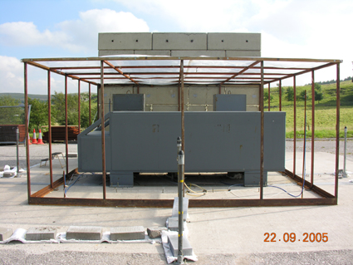 | 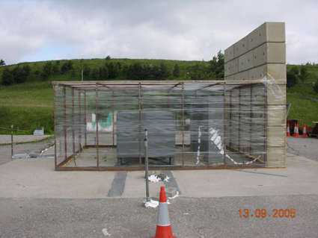
Figure 1 Front view of the rig | Figure 2 Side view of the rig with polythene film
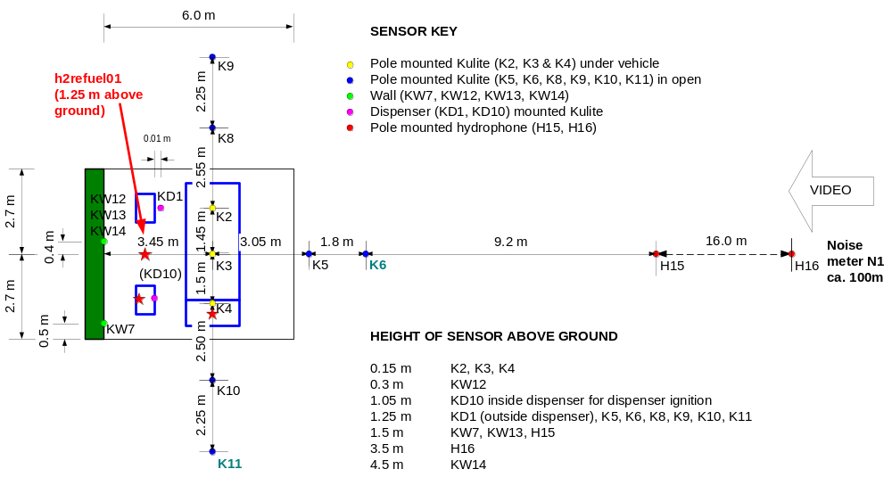
Figure 3 Sensor locations
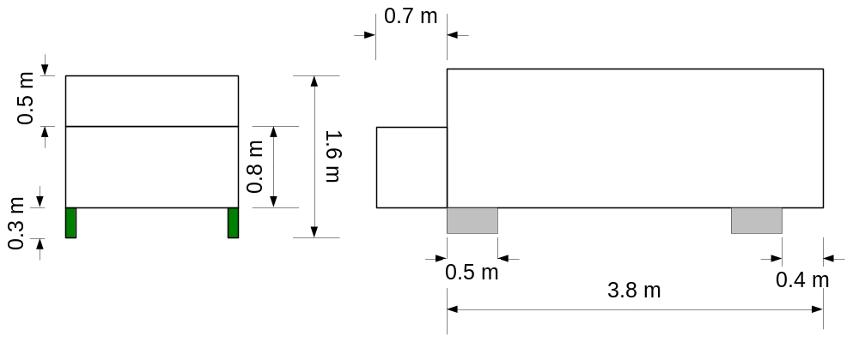
Figure 4 Schematic drawing of the vehicle

Experiment ID | FZK hydrogen distribution tests in free turbulent jet
Short description | Hydrogen distribution tests in horizontal free turbulent jet have been carried out in a compartment with an internal volume of 160 m³. Experimental facility consisted of high pressure gas system to provide hydrogen release at pressures in the range 20 – 260 bar through the nozzle (Figs. 1, 2). Hydrogen concentration profile and flow velocity were simultaneously measured in three different cross-sections at distances 0.75, 1.5, and 2.25 m from the nozzle (Fig. 3). Experiments were made in order to evaluate amount of burnable hydrogen – air mixture (above the lower flammability limit) in free turbulent jet at different pressures.
What phenomena were studied | Effects of initial pressure and nozzle size on hydrogen distribution and flow velocity in free turbulent jet.
What phenomena/effects can be validated | Effects of initial pressure and nozzle diameter on turbulent jet behavior can be validated.  Axial and transverse hydrogen distribution in free turbulent jet can be validated.  Evolution of the flow velocity in free jet can be validated.
Instrumentation | High pressure gas system with pressure and flow rate control used high speed valves and Prandtl pitot tubes and Coriolis sensor for mass flow control.  2D positioning measurement system 2x2.5 m based on ultrasonic sensors of hydrogen concentration.  Ultrasonic hydrogen sensor has 10 cm spatial resolution. Accuracy of the method is ± 0.1 %.
Test variables | Initial pressure 20 – 260 bar  Nozzle diameter 0.16 – 1 mm  Hydrogen mass flow rate 0.2 – 8 g/sec
Data description / Data completeness | All concentration profiles and flow velocity data are in digital format.
Data availability | Restricted currently.
Source of data / Reference | Contract report BM 3444044, 2005
Why were chosen | No similar results elsewhere are available
Relevance to the project purposes | Hydrogen release from pressurized vessel. Dynamic hydrogen concentrations and flow velocity profiles are valuable for experimental validation of numerical models of hydrogen free jets. Flammability of the turbulent hydrogen jet.

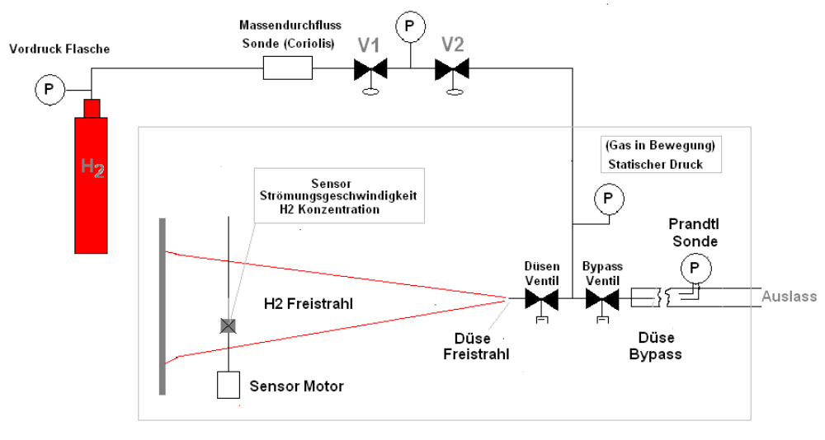  H2 free jet  Nozzle  Ultrasonic sensor:  H2 – concentration  flow velocity  H2300 bar  Flow rate  Coriolis sensor  Outlet  Nozzle  valve  Bypass valve | 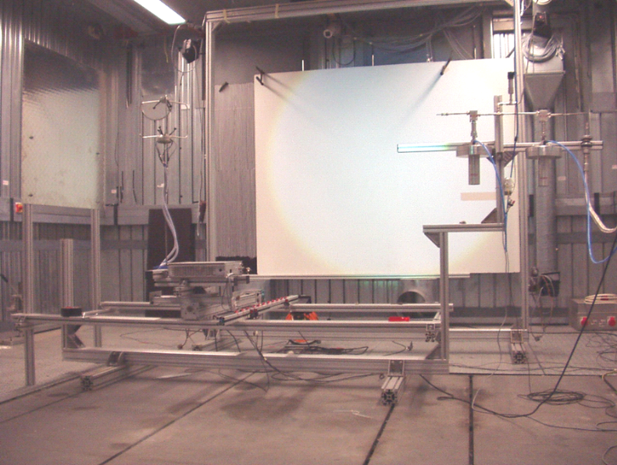
Figure 1 Hydrogen injection system | Figure 2 Side view of the experimental set-up
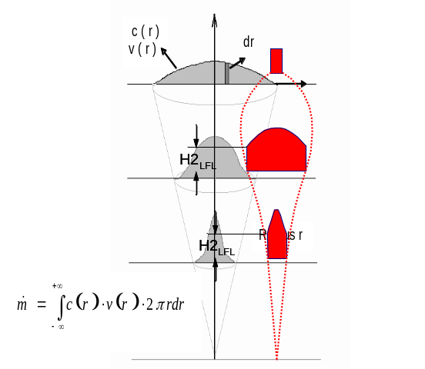

Figure 3 Hydrogen and velocity distribution in free jet

Experiment ID | HSL Un-ignited High-Pressure Hydrogen Releases in the Atmosphere – Experiment no. 7
Short description | A set of experiments involving horizontal high-pressure hydrogen jet releases was conducted at HSL. Different release pressures and nozzle diameters were used.
What phenomena were studied | The hydrogen concentration was measured at a number of locations along the (perceived) centreline of the jet. Figures 1 and 2 show the experimental set-up from two different angles. Figure 3 shows the locations of the oxygen concentration sensors.
What phenomena / effects can be validated | Hydrogen concentrations in the horizontal direction. These concentrations are derived from the oxygen sensor readings
Instrumentation | 13 CiTicel AO2 oxygen concentration sensors were located between 3 m and 11 m from the release point, see Figure 3 below.
Test variables | Different release pressures, ranging from 1.1 MPa to 13.7 MPa, and different nozzle diameters, e.g. 3 mm, 4mm, 6 mm and 12 mm. Ambient wind conditions were also recorded. The experiment, no. 7, chosen here was conducted at near-still conditions.
Data description / Data completeness | All concentration data are available in digital format.
Data availability | Restricted to Shell Hydrogen Projects BV, Shell Global Solutions and HSL currently, but the data will be made available to the HySafe partners.
Source of data / Reference | Shirvill, L. C., Roberts, P. T., Roberts, T. A., Butler, C. J. and Royle, M., Dispersion of hydrogen from high-pressure sources, presented at Hazards XIX Conference in Manchester, UK, 27-30 March 2006.
Why were chosen | No similar experiments have been carried out, to our knowledge. We also have ready access to the raw data.
Relevance to the project purposes | Provides information relating to high-pressure jet releases in the atmosphere. The experiments will provide an opportunity to investigate the best way to represent high-pressure jets. Most, if not all, accidental releases are likely to involve high reservoir pressure so that the flow would be sonic.

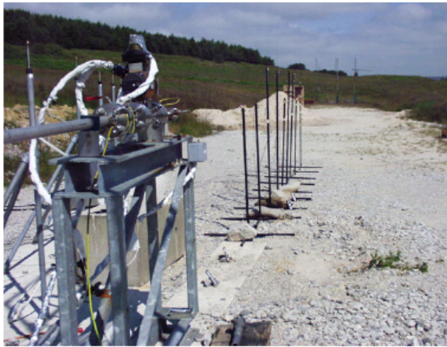 | 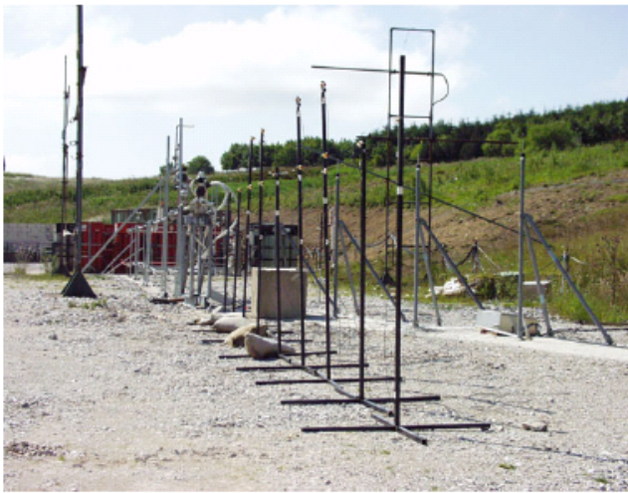
Figure 1 Experimental setup, viewed from upstream of the nozzle | Figure 2 Experimental setup, looking towards the nozzle

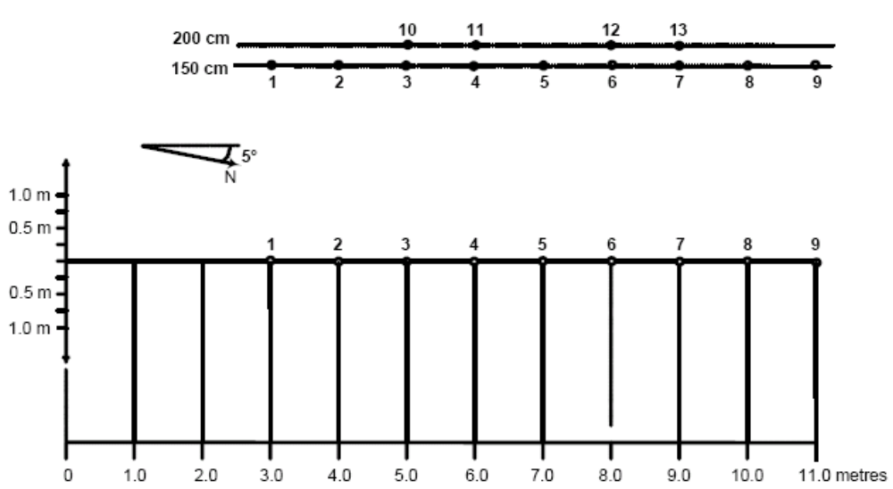
Figure 3 Location of the oxygen concentration sensors

1. Low momentum jets by GEXCON-NH-STATOIL

Test Parameters:
Scale: Small
Confinement: Partial
Congestion: Moderately high

Test Usability:
Data available for comparison: H₂ volume percent

Test Date: 2003

Test Number for consideration: D27 (low momentum)

Test Description:

GEXCON, NH and STATOIL (GEXCON, 2003) have performed hydrogen dispersion experiments in a confined compartmented space (see Figure 1). Tests D06, D27 and D58 are shared within the HYSAFE project. For the purpose of validation, only the low momentum test D27 needs to be simulated.

The experimental rig consists of a 1.20 m × 0.20 m × 0.90 m vessel (Z vertical), divided into compartments by use of baffle plates with dimensions 0.30 m (Z) × 0.20 m (Y). The thickness of the baffles is less than 5mm. Four vertical baffle plates were used in test D27 (see Figure 2). There is one vent opening at the wall opposite the release location centrally located about 1 cm above floor with dimensions 0.10 m (Y) × 0.20 m (Z).

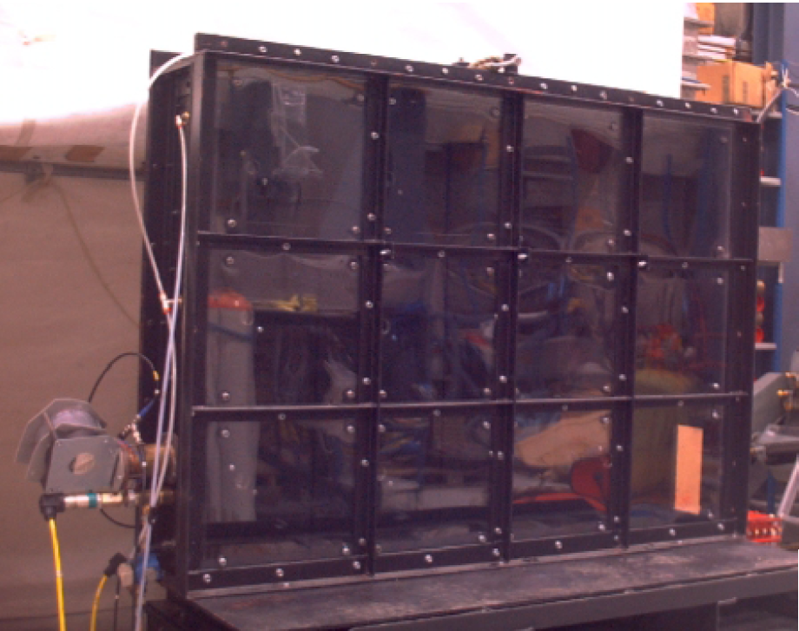

Figure 1. Photograph of the test rig

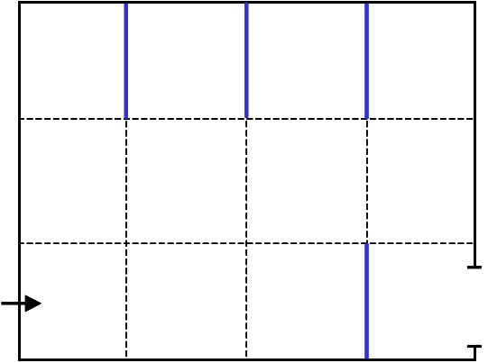

Figure 2. Geometry configuration C1 (test D27)

The release conditions and exact location of the jet exit for the three tests are given in Table 1 below. The temperature in the geometry as well as the ambient temperature was 20C. The temperature of the hydrogen release was estimated to be between 0-5C.

Table 1: Release conditions

Test ID | Release period (s) | Nozzle diameter (mm) | Exit velocity (m s⁻¹) | Flow rate (Nl s⁻¹) | X_{jet} (m) | Y_{jet} (m) | Z_{jet} (m)
D27 | 60 | 12 | 10.17 | 1.15 | 0.03 | 0.1 | 0.145

Hydrogen concentrations were recorded at 12 locations in the rear wall (see Figure 3), using Oldham sensors type OLCT20D. They were located flush on the wall, but they had a small physical thickness (around 1cm). The sensors are of the chatarometric type, which means that they are based on the measurement of the thermal conductivity of hydrogen compared to air.

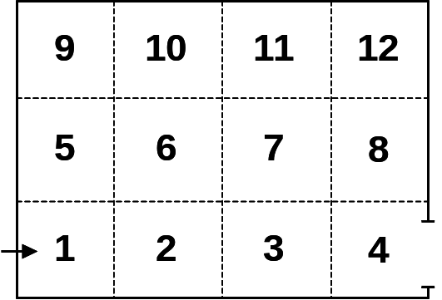

Figure 3. Sensor posistions

The gas supply was fed to the experiment by means of a high pressure hose (1/4”) via an electrically controlled solenoid “release” valve, located just upstream of the release nozzle. Prior to a dispersion test, this gas line was pressurised to the desired dispersion line pressure and the actual gas release controlled automatically by the test sequence control and data acquisition system, which opened and closed this “release” valve according to the desired release duration.
The gas supply was mixed using a specially built mixing panel (shown in Figures 4 and 5). By using a combination of fixed volume gas containers at equal pressures and outlets via non-return valves, gas mixtures, having the desired composition could be made upstream of the gas release valve. A schematic diagram of the mixing panel is shown below.
There was no bend but a restriction through the valve. Also, for the test D27, the gas tested was pure H₂ and so any description of N₂ in the figures below can be ignored.

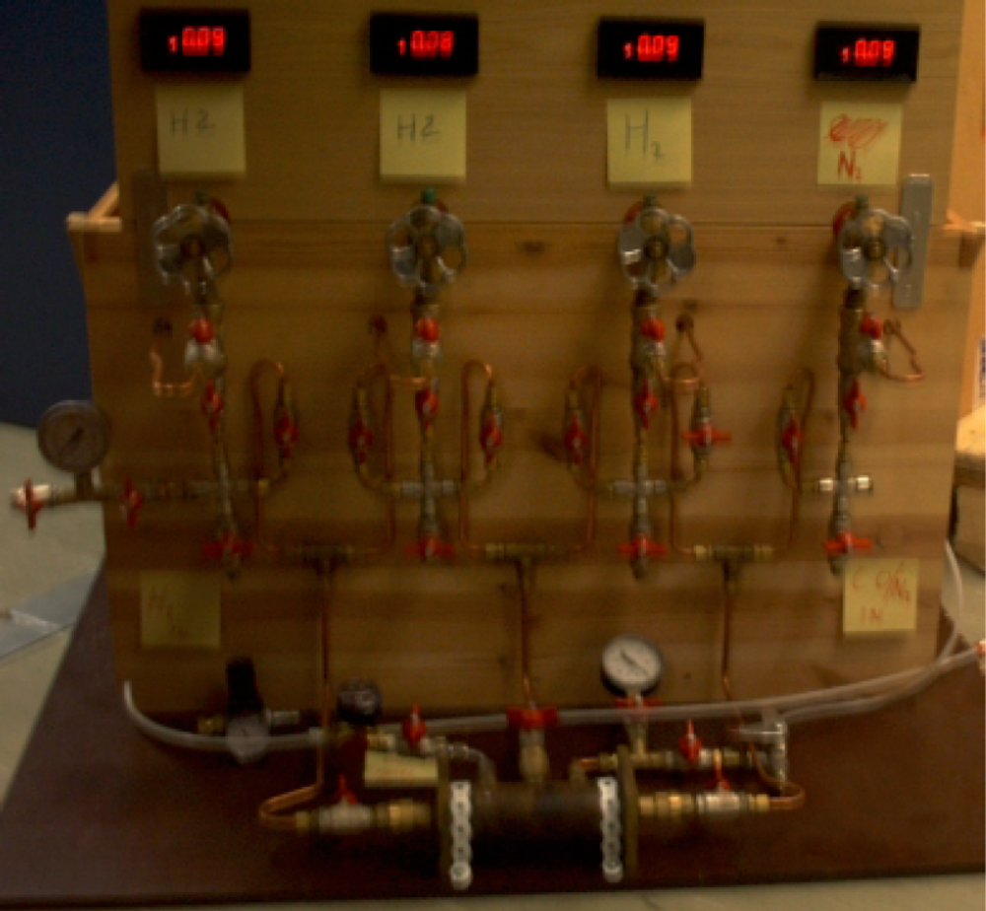
Figure 4. Photograph of the two component mixing panel

The available dataset consists of transient gas dispersion recordings in excel format for 12 monitor locations for the first 120 s.

Through the test series some problems with the gas concentration measurements were experienced for certain sensors (3, 6, 11). A negative concentration was often seen for a short period before sensors “recovered” and seemed to give good results. Sensor 4 frequently became unstable, and is suspected to give consistently poor results. Some tests were carried out swapping sensors, and these confirmed poor behaviour of the mentioned sensors.

The available dataset consists of transient gas dispersion recordings in excel format for 12 monitor locations for the first 120 s. The following presents the plots of gas concentrations vs. time for 8 of the monitor points (excluding the ones which had problems). Figure 6 shows the values obtained for sensors 1 and 2. Figure 7 presents the values for sensors 5, 7, and 8. In Figure 8, the observed concentrations for sensors 9, 10, and 12 are plotted. For these sensors, it is important to capture the fact that the concentration for sensor 12 begins to increase much later compared to sensors 9 and 10 owing to the fact that it takes much longer to fill gas in the region where sensor 12 is present. It is recommended to compare the maximum concentrations (c_{max}), time of arrival of maximum concentrations (t_{max}), the time to reach a concentration of 15 vol% (t₁₅) to estimate the difference in rise times of the gas concentration, and the concentration at t = 100 s (c₁₀₀) to estimate the slope of the decay of concentration (if any). These evaluation parameters are presented in
Table 2. Please note that the gas concentrations reach a steady value for sensors 5, 9, and 10, and therefore, the maximum values do not have a lot of meaning (and only captures experimental fluctuations). For these sensors, a comparison of the steady state concentrations is more instructive.

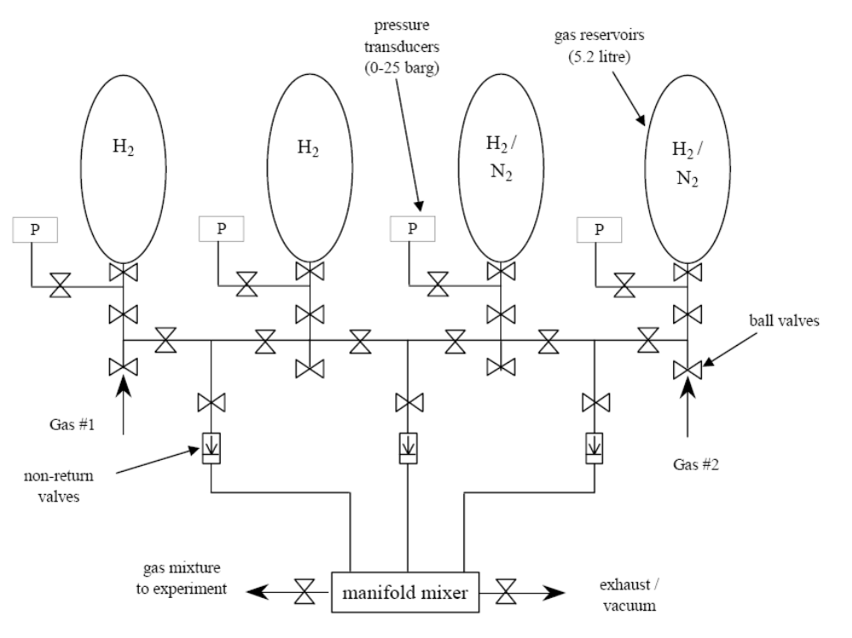

Figure 5. Schematic diagram of the two component mixing panel

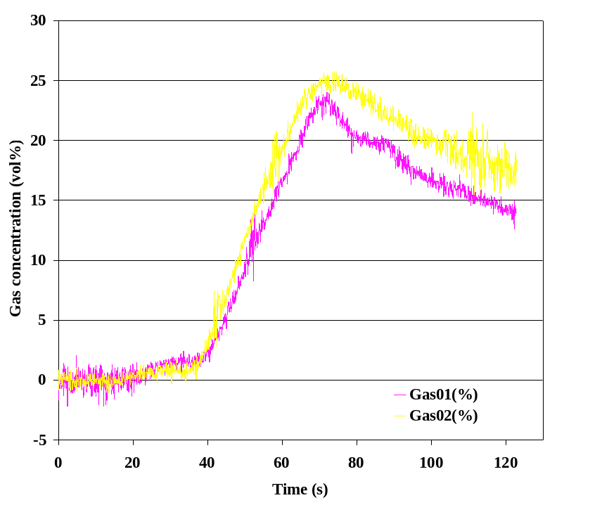

Figure 6. The variation of gas concentration with time for sensors 1 and 2 (GexCon tests)

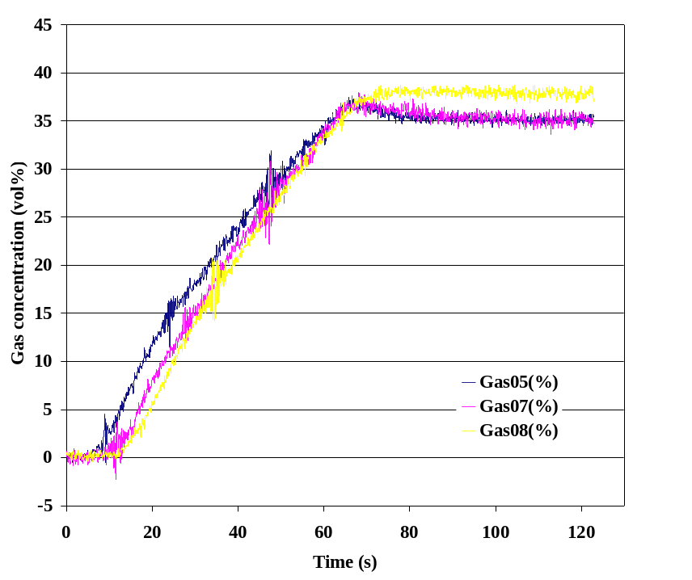

Figure 7. The variation of gas concentration with time for sensors 5, 7, and 8

Figure 8. The variation of gas concentration with time for sensors 9, 10, and 12 (GexCon tests)

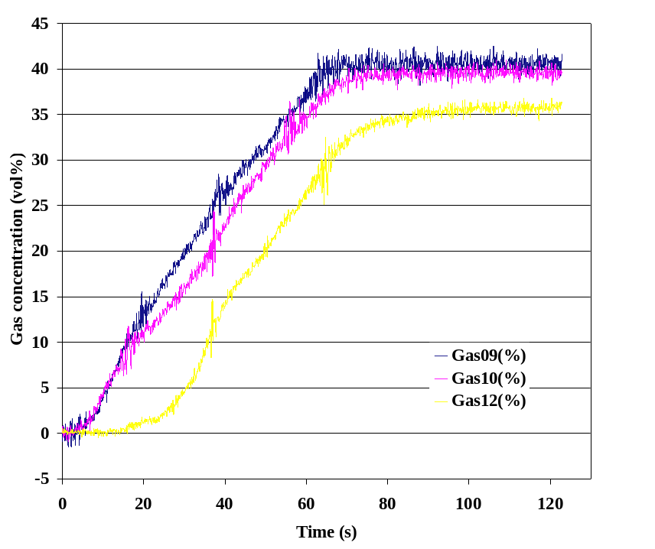

Table 2. Evaluation data for the low momentum jets

Sensor | t_{max} (seconds) | c_{max} (vol%) | t₁₅ (seconds) | c₁₀₀ (vol%)
1 | 72.0 | 24.0 | 57.9 | 16.6
2 | 74.0 | 25.7 | 53.8 | 19.5
5 | 65.7 | 37.4 | 25.0 | 35.6
7 | 68.0 | 37.9 | 29.4 | 35.2
8 | 98.3 | 38.7 | 31.4 | 37.9
9 | 92.2 | 42.4 | 23.2 | 39.7
10 | 106.7 | 41.0 | 28.9 | 40.6
12 | 113.5 | 36.8 | 41.7 | 35.8

Experiment ID | HYCOM experiments on flame acceleration in vented tube
Short description | Combustion experiments have been carried out in obstructed tube of 174 mm i.d. and 12.2 m long (DRIVER facility). Repeatable obstacles with blockage ratios 0.3 and 0.6 at distances equal to i.d. were installed.  Two typical hydrogen-air mixtures with concentrations of 10% H₂ (for subsonic deflagration) and 13%H₂ (for sonic deflagration) have been tested in a tube with different end venting. Ignition at various distances from the open tube. After some distance from the vent orifice flame behaviour becomes the same as for closed tube.
What phenomena were studied | Effects of the venting and ignition position from the open end on flame acceleration in obstructed tube
What phenomena/effects can be validated | Effects of initial vent ratio on turbulent flame propagation in obstructed channel with end venting for subsonic and sonic regimes can be validated.  Insensitivity of flame propagation to the opening after some distance from the orifice can be validated.
Instrumentation | Two types of pressure transducers (1) piezoresistive transducers D06 (natural frequency 1 kHz), and (2) piezoelectric transducers PCB-H113A (frequency 100 kHz).  Collimated germanium photodiodes (up to 23) for measurement of the time-of arrival of the flame front. Time resolution of 10 μs.
Test variables | Vent ratios 0-100%  Ignition position 0 – 6.5 m  Hydrogen concentration in air 10% and 13%  Blockage ratio 0.3 and 0.6
Data description / Data completeness | All pressure and photo-diode recordings in digital form
Data availability | Publicly accessible
Source of data / Reference | Technical Report: EU Project HYCOM, 2004; W. Breitung, S. Dorofeev, A. Kotchourko et al. Integral large scale experiments on hydrogen combustion for severe accident code validation-HYCOM. Nuclear Engineering and Design 235 (2005) 253–270
Why were chosen | Very well instrumented, complete description, by the moment no similar results elsewhere are available
Relevance to the project purposes | Can address separate phenomena, which are of primary interest for the project purposes.

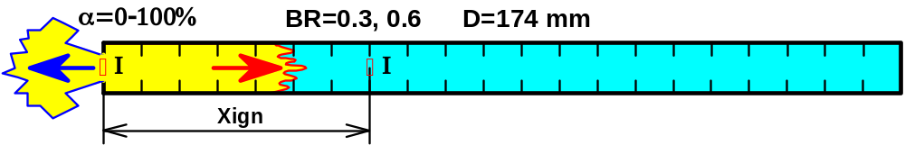
Figure 1: Obstructed detonation tube with end venting: α = 0-100% is a vent ratio; I are ignition positions.
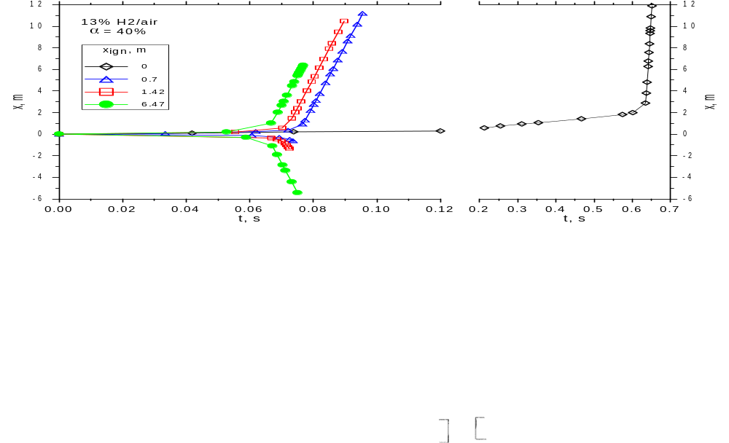  Figure 2 X-t diagram of the flame propagation for different ignition positions  and vent ratio α = 40%. | 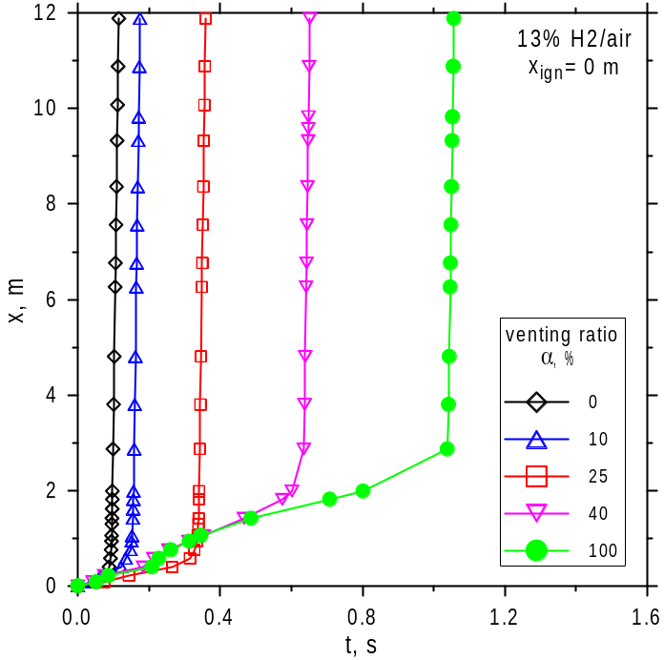  Figure 3 X-t diagram of the flame propagation from the open end (X_{ign} = 0 m) and at various vent ratios α = 0-100%.

Experiment ID
Short description | 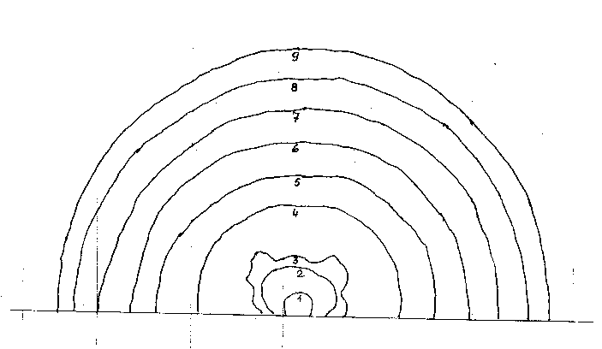  Detonation of 29.05% (by vol.) hydrogen-air quiescent mixture in the 53 m³ hemispherical balloon (diameter 2.93 m). Central point ignition source. Initial temperature is 304 K, initial pressure 99.9 kPa.
What phenomena were studied | Detonation and blast wave propagation in open atmosphere.
What phenomena/effects can be studied | Propagation of the detonation wave, pressure build up and pressure of the blast wave in the far field
Instrumentation | Pressure transducers, high speed video.
Test variables | Hydrogen concentrations (only 29.05% H₂-air mixture is offered for SBEP).
Data description / Data completeness | Pressure records at 0.75, 1.5, 2.75, 3.25, 5.0, 7.5, 1.0, 2.25, 4.0, 6.25, 10 m from ignition source.
Data availability | Publicly unavailable (Fh-ICT report).
Source of data / Reference | Pfortner H.; Ausbreitungsfunktionen detonierender Wasserstoff-Luft-Gemische; Fraunhoffer-Institut fur Chemische Technologie; FhG-Projekt Nr.102555
Why were chosen | Convenient basic benchmark case to evaluate a model performance for: detonation front propagation, pressure dynamics.
Relevance to the project purposes | Large scale detonation in open space is a potential explosion scenario. Relevant to hydrogen explosion safety (WP10 “Hydrogen explosions”) and safety distances calculation (WP11 “Safety Measures”).

Experiment ID
Short description | 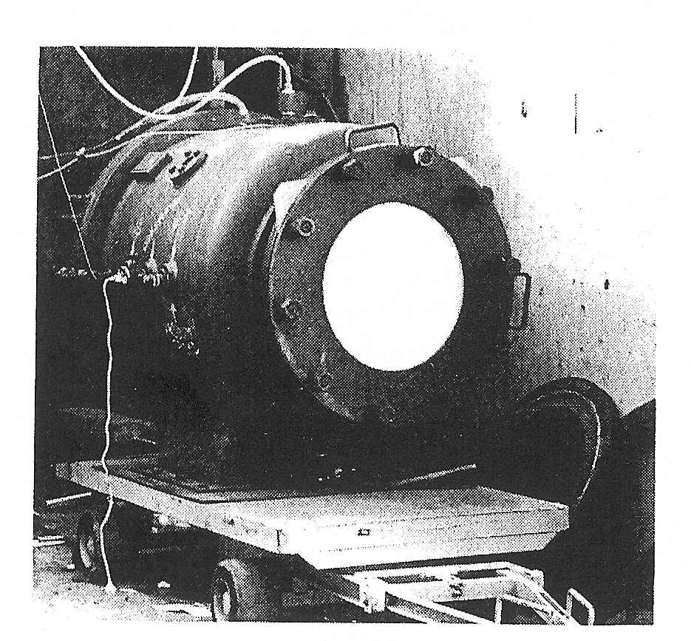  Experiments on 29.6% H₂-air explosions in a 1 m³ vessel, closed and vented through 0.3 and 0.2 m² openings.
What phenomena were studied | Pressure reduction by venting
What phenomena/effects can be studied | H₂-air vented explosion, deflagration-outflow interaction during venting
Instrumentation | Piezoelectric pressure transducers
Test variables | Vent area: 0.0, 0.2 and 0.3 m².
Data description / Data completeness | Smoothed experimental pressure dynamics data for: closed vessel explosion, vent areas 0.2 and 0.3 m².
Data availability | Publicly available.
Source of data / Reference | Pasman H.J., Groothuisen Th.M. and Gooijer P.H. Design of Pressure Relief Vents, in “Loss Prevention and Safety Promotion in the Process Industries”, Ed. Buschman C.H., Elsevier, New-York, 1974, pp.185-189.
Why were chosen | Experiment on a vented H₂-air deflagration, relevant to H₂-air explosion mitigation by venting. Benchmark exercise to evaluate a model for explosion mitigation by venting.
Relevance to the project purposes | Vented experiment relevant to hydrogen explosion mitigation (WP11 “Safety Measures”).

Experiment ID
Short description | Deflagration of a 30 % H₂-air homogeneous mixture contained within a 37 m³ volume (1 kg H₂) located at the centre of a 78.5 m long and 3.74 m² cross-sectional area tunnel with and without obstacles, which represented a vehicle tunnel at about 1/5 scale.  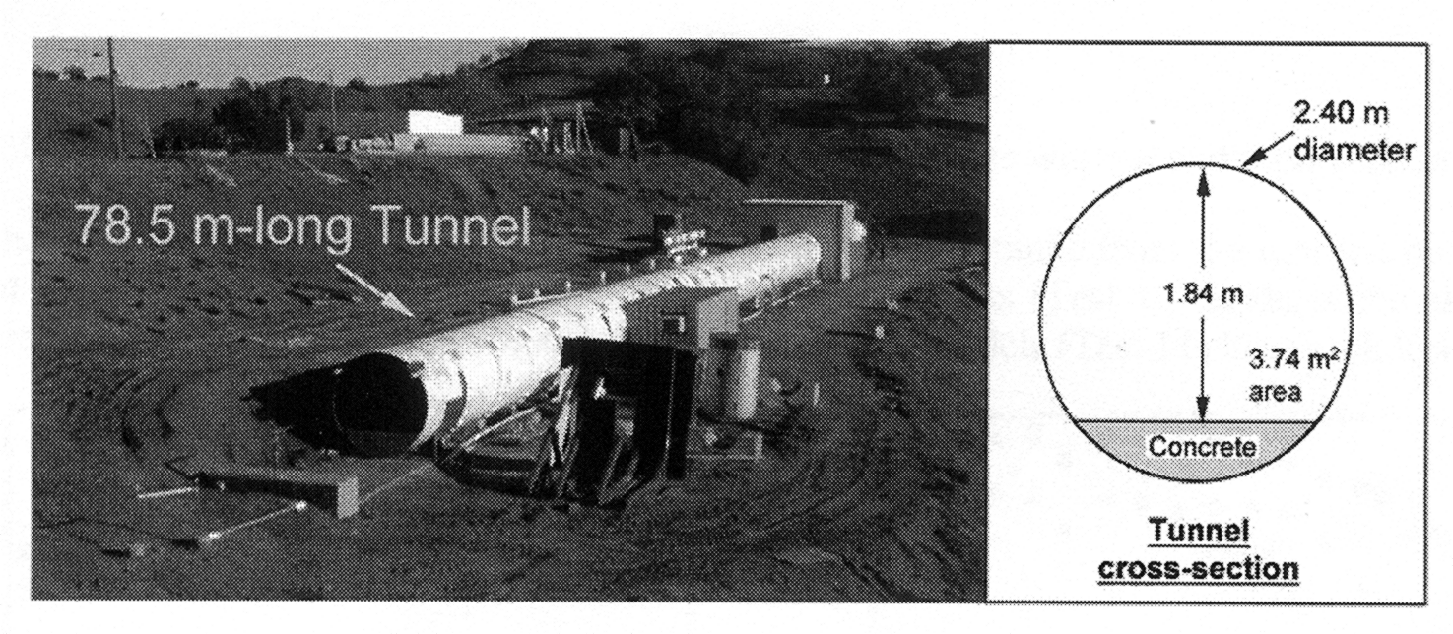
What phenomena were studied | Combustion and pressure wave propagation within the tunnel from centrally located ignition point in initially quiescent mixture.
What phenomena/effects can be validated | Pressure dynamics near the tunnel end with and without vehicle models for 30 % H₂-air homogeneous mixture.
Instrumentation | Pressure transducers, video cameras to obtain flame contours.
Test variables | Deflagration inside tunnel with/without vehicle models (BR = 0.03)
Data description / Data completeness | Pressure dynamics at 34 m; overpressures at distances 1 m, 1.7 m, 2.2 m, 2.8 m, 3.6 m, 4.8 m, 6.2 m, 8 m, 105 m, 14 m, 18 m, 22 m, 30 m, 34 m.
Data availability | Publicly available
Source of data / Reference | 1. Groethe, M., Merilo, E., Colton, J., Chiba, S., Sato, Y., and Iwabuchi, H., “Large-scale Hydrogen deflagrations and detonations”, International Conference on Hydrogen Safety, Pisa, Italy, 8-10 September 2005. ISBN 88-8492-314-X
Why were chosen | Large-scale experiment on hydrogen-air deflagration inside a tunnel, relevant to realistic H₂ explosion scenario.
Relevance to the project purposes | Relevant to IP2 “HyTunnel”.
Experiment ID
Short description
  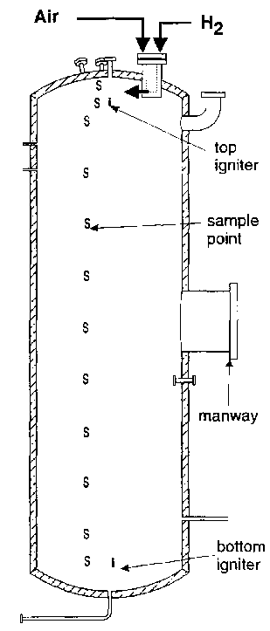 | Hydrogen combustion experiments in stratified and uniform H₂-air mixtures in a vertical 10.7 m³ closed vessel.
What phenomena were studied | Flame front propagation and pressure dynamics for top and bottom located ignition sources in both uniform and stratified hydrogen-air mixtures.
What phenomena/effects can be studied | Explosion dynamics for flame propagation in and against the direction of concentration gradient.
Instrumentation | Pressure transducers, H2 concentration samples, thermocouples to obtain flame arrival time.
Test variables | Concentration gradient, average concentration, ignition location. Tests with varying ignition location, for which pressure dynamics is known, are offered for SBEP.
Data description / Data completeness | 1. Pressure dynamics and flame arrival time for top-ignited H2-air stratified mixture, corresponding to average 12.6% H2 concentration (pressure dynamics for uniform 12.8% H2-air mixture is available for comparison).  2. Pressure dynamics for bottom-ignited H2-air stratified mixture, corresponding to average 13.4% H2 concentration (pressure dynamics for uniform 12.4% H2-air mixture is available for comparison).
Data availability | Publicly available.
Source of data / Reference | Whitehouse D.R., Greig D.R., Koroll G.W., 1996. Combustion of Stratified Hydrogen-Air Mixtures in the 10.7 m3 Combustion Test Facility Cylinder. Nuclear Engineering and Design, V.166, pp.453-462
Why were chosen | Large-scale experiment on hydrogen-air deflagration in closed vessel (published in peer reviewed journal), relevant to realistic scenario of stratified H2-air mixture explosion. Benchmark exercise to evaluate a model performance for flame front propagation in non-uniform mixtures.
Relevance to the project purposes | Large scale of the experiment and stratified mixture distribution are relevant to the realistic hydrogen explosion, WP10 “Hydrogen explosions”, IP2 “HyTunnel”.

Experiment ID | KI RUT hyd5
Short description | Test 1st of 2 (hyd5, hyd9). Detonation experiments have been carried out in large scale confined complex geometry (263 m³). Uniform hydrogen/air mixture with concentration of 20.0% H2 was tested. Ignition in the canyon (A).
What phenomena were studied | Detonation wave propagation and pressure loading in the complex confined geometry
What phenomena/effects can be validated | Detonations, pressure loading
Instrumentation | Measurements include 12 piezoelectric transducers.
Test variables | Hydrogen concentration, ignition point
Data description / Data completeness | Pressure recordings in digital form
Data availability | Publicly accessible
Source of data / Reference | Report RRCKI-80-05/59  Reference: W. Breitung, S.B. Dorofeev, A.A. Efimenko, A.S. Kochurko, R. Redlinger, V.P. Sidorov. Large Scale Experiments on Hydrogen-Air Detonation Loads and Their Numerical Simulation. Proc. 20th Int. Symp. on Shock Waves, Pasadena, CA, USA, 1995, p. 405
Why were chosen | Well instrumented, complete description
Relevance to the project purposes | Series of two experiments can be used as integral experiments for the code validation on detonation wave propagation and pressure loading in complex geometries on scales relevant to industrial.

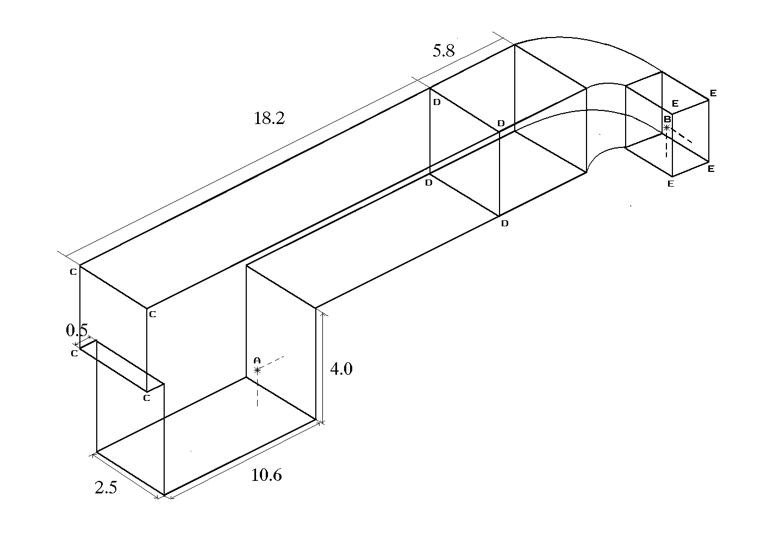

A, B - initiator locations; C, E - steel plates locations

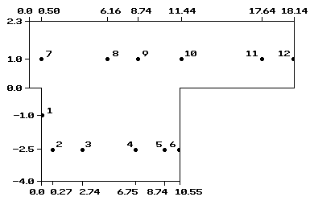

Scheme of transducers location in RUT facility.

Experiment ID | KI RUT hyd9
Short description | Test 2nd of 2 (hyd5, hyd9). Detonation experiments have been carried out in large scale confined complex geometry (263 m³). Uniform hydrogen/air mixture with concentration of 25.5% H2 was tested. Ignition in the channel (B).
What phenomena were studied | Detonation wave propagation and pressure loading in the complex confined geometry
What phenomena/effects can be validated | Detonations, pressure loading
Instrumentation | Measurements include 12 piezoelectric transducers.
Test variables | Hydrogen concentration, ignition point
Data description / Data completeness | Pressure recordings in digital form
Data availability | Publicly accessible
Source of data / Reference | Report RRCKI-80-05/59  Reference: W. Breitung, S.B. Dorofeev, A.A. Efimenko, A.S. Kochurko, R. Redlinger, V.P. Sidorov. Large Scale Experiments on Hydrogen-Air Detonation Loads and Their Numerical Simulation. Proc. 20th Int. Symp. on Shock Waves, Pasadena, CA, USA, 1995, p. 405
Why were chosen | Well instrumented, complete description
Relevance to the project purposes | Series of two experiments can be used as integral experiments for the code validation on detonation wave propagation and pressure loading in complex geometries on scales relevant to industrial.
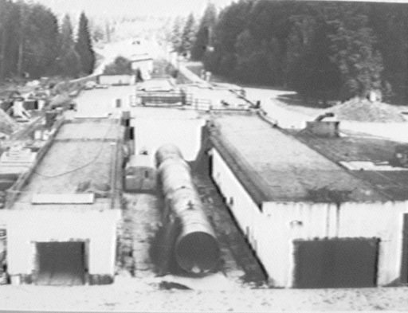 General view of the RUT facility.
Experiment ID | PET tests
Short description | Deflagration of different H₂-air homogeneous mixture in combustion tube with adjustable transverse venting varying from 0% to 40%. Comparison of terminal flame speed and FA conditions for H₂-air and hydrocarbon mixtures (CH4, C3H8).  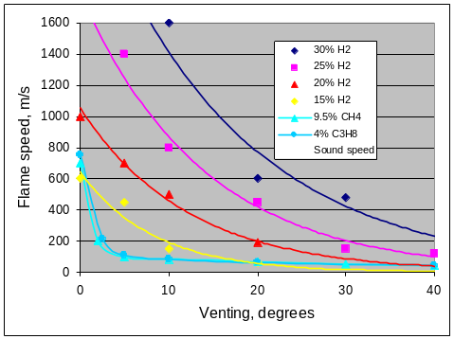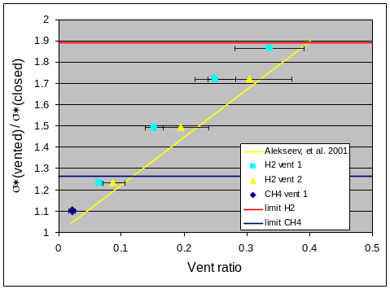  100  250  775  1300  1825  2315  2875  3400  3925  4450  4600  345  400  870  1395  1920  2435  2960  3485  4010  4743  100  id  Positions for pressure transducers and photodiodes, mm from ign  ition  96  63  Spacing: 100 mm  Thickness of the  plates: 10 mm  Orifice plate obstacles  Mutual  position  of inner  tube,  outer  tube, and  frame  Vent positions  Experimental
What phenomena were studied | FA and combustion propagation within the tube under transverse venting.
What phenomena/effects can be validated | Prediction of FA and terminal flame speeds in different fuel-air mixtures.
Instrumentation | Pressure and light transducers, video for general overview.
Test variables | Fuel concentration, BR, vent ratio
Data description / Data completeness | Pressure and light signals vs time. All data digitized
Data availability | Available as property of FZK
Source of data / Reference | FZK internal reports
Why were chosen | Hydrogen-air deflagration of accidental releases in partially vented environment. Comparison with conventional fuels.
Relevance to the project purposes | Direct link

APPENDIX



